Spark

Jobnest

IT20642914 – Gamage B.G.A.C

IT20641092 -Wijesinha W.S.S.

IT20637064 – Anuththara R.M.C

IT20639662 – Navodi P.T

SEJ006

User Experience Engineering SE3050

Department of Computer Science and Software Engineering, Faculty of Computing, Sri Lanka Institute of Information Technology (SLIIT)

Declaration

We declare that this is our own work, and this report does not incorporate without acknowledgment any material previously submitted for a degree or diploma in any other university or institute of higher learning, and to the best of my knowledge and belief it does not contain any material previously published or written by another person except where the acknowledgment is made in the text. Also, we hereby grant to Sri Lanka Institute of Information Technology the non-exclusive right to reproduce and distribute our report in whole or part in print, electronic, or another medium. We retain the right to use this content in whole or part in future works (such as articles or books).

|  |  |  |  |
| --- | --- | --- | --- |
| Student No. | Name | Date | Signature |
| **IT20642914** |  |  |  |
| It20641092 |  |  |  |
| IT20637064 |  |  |  |
| IT20639662 |  |  |  |

# Abstract

Nowadays, Education is a most important thing in the world. Most of the parents try their best to give a good education for their children. But the economic problems are avoided those education opportunities of children. Other thing is, there are limited universities in Sri Lanka to get a higher education. So, most of the children are going to do a job after their A/L s. Therefore, considering those problems, we planned to design a mobile application to solve those problems.

This report shows what are the steps we have followed since beginning to last to design this application. It shows user feedbacks under many steps also. The purpose of this report is giving a clear idea about steps and tasks which we have done to readers.

In here, mainly we addressed the areas of learner, teacher, tech expert and course authorizer as stakeholders and their functions for the application. We used Android Studio to developed this. After adding suitable and beneficiary functions we suggested an E-learning mobile application to solve the all problems which we have mentioned above.

We all conclude that the application we have designed will give more benefits to learners.

Table of Contents

Declaration 1

Abstract 2

List of Figures 6

List of Tables 7

List Of Abbreviations 8

1 Introduction 9

2 Background 10

2.1 SDG selection 10

2.2 Design Purpose 10

2.3 Team Members 10

2.4 Contribution Table 10

3 Design Process 11

3.1 User Involvement 11

4 Milestone 1: Identify user groups 12

4.1 Persona(s) – 04 personas from a group 12

4.2 Empathy map(s) – 04 Empathy maps from a group 12

4.3 User stories – 04 User stories from a group 12

4.4 User flow(s) - 04 User flows from a group 12

4.5 Service Blueprint(s) – 01 Service Blueprint from a group 12

5 Milestone 2: Plan and conduct user research 13

6 Milestone 3: Verify the key-user flow(s) 14

7 Milestone 4: Sketching, Wireframes, Prototype, User Feedback for your Prototype 15

8 Milestone 5: Implementation 16

9 Competitor Analysis 17

9.1 <Competitor 1> 17

9.2 Advantage 17

9.3 Disadvantage 17

9.4 Translation 17

9.5 <Competitor 2> 17

9.6 <and so on …> 17

10 Requirement Specification 18

10.1 Usability Goals 18

10.2 User Experience Goals 18

10.3 Functional Requirements 18

10.4 Non-Functional Requirements 18

10.5 Hierarchical Task Analysis 18

10.5.1 <Task 1> 18

11 Design Principles 19

12 Low Fidelity Prototype 20

12.1 Design 1 20

12.2 Design 2 - accepted 20

13 High Fidelity Prototype 21

13.1 Design 1 21

13.2 Design 2 - accepted 21

14 Project Management 22

14.1 Meetings 22

14.2 Risk Management 22

14.3 Milestones 22

14.4 Problems Encountered 22

15 Conclusion 23

References 24

Glossary 25

Appendix 26

15.1 Initial User Survey Responses 26

15.2 Meeting Minutes 26

15.3 Record Keeping 26

15.4 Toggl tracking 26

15.5 Links to Google Docs / MS Teams 26

15.6 Contribution Table 26

**Tip #1:** The purpose of this template is to ensure you cover the main content required in your report. However, this report template is not absolute. You can add or replace some sections if needed. Marks depend on the quality of the content of the report.

**Tip #2:** There is no minimum or maximum page limit, Note, the report must be professionally and succinctly written with emphasis on clarity. Content that is not essential should not be included. There may be a suggested word limit for some sections.

**Tip #3:** Although not essential, you may choose your own document template to deliver a beautifully presented industry-ready report.

**Tip #4:** Read this whole document early in the course.

# Background

## SDG selection

Describe the solution you are designing to the selected SDG.

* Provide some context on the project domain e.g. explanation, problems, and needs.
* Explain why you chose this project.
* Who are the users, why is this solution important and helpful to them?
* Describe the purpose and the design issues you addressed when designing this.
* Screenshots can help to provide visual cues.

## Design Purpose

We have designed the GUI considering the user feedbacks. We want to give a user-friendly, attractive and usability application. That is the goal which we want to achieve from our GUI. So we followed user feedbacks and designed an application with user-friendly, attractive and usability GUI.

## Team Members

* Gamage B.G.A.C Member 1 (Leader)
* Wijesinhe W.S.S Member 2
* Anuththara R.M.C Member 3
* Navodi P.T Member 4

## Contribution Table

|  |  |  |
| --- | --- | --- |
| **Student No** | **Student Name** | **Individual Contribution** |
| IT20642914 | Gamage B.G.A.C | Abstract  Created list of figures  Created list of tables  Background  Contributed to complete all milestones  Analysing competitor 1  Contributed to finalize the report |
| IT20641092 | Wijesinhe W.S.S | Introduction  Background  Design process  Contributed to complete all milestones  Analysing competitor 1  Contributed to finalize the report |
| IT20637064 | Anuththara R.M.C | Requirement specification  Design principles  Project management  Contributed to complete all milestones  Analysing competitor 2  Contributed to finalize the report |
| IT20639662 | Navodi P.T | Conclusion  References  Appendix  Contributed to complete all milestones  Analysing competitor 2  Contributed to finalize the report |

# Design Process

Problem-solving techniques such as design thinking are used. When used to unknown, difficult problems, it is helpful. since it helps us to understand what others need.

The ideal setting for truly comprehending the customer's voice can be created with the aid of design thinking.

## User Involvement

Users are the most important thing when we are designing an application. So, we should involve them to our design process. We planned to involve them since our early stages in our project.

First, we got their ideas about the application which we are going to develop by conducting interviews and distributing a google form. Then we got the user feedbacks for the wireframes which we have drawn. After that we redrew those wireframes and re designed the prototype considering the user feedbacks.

We wanted to confirm whether our finalized wireframes are satisfied by users. So again, we conducted an interview and got user feedbacks for our finalized user interfaces. After implement the overall product we plan to publish our application on social media and get user feedbacks.

This is the way that we involved and will involve the user in the user-centred design process.

# Milestone 1: Identify user groups

## Persona(s) – 04 personas from a group

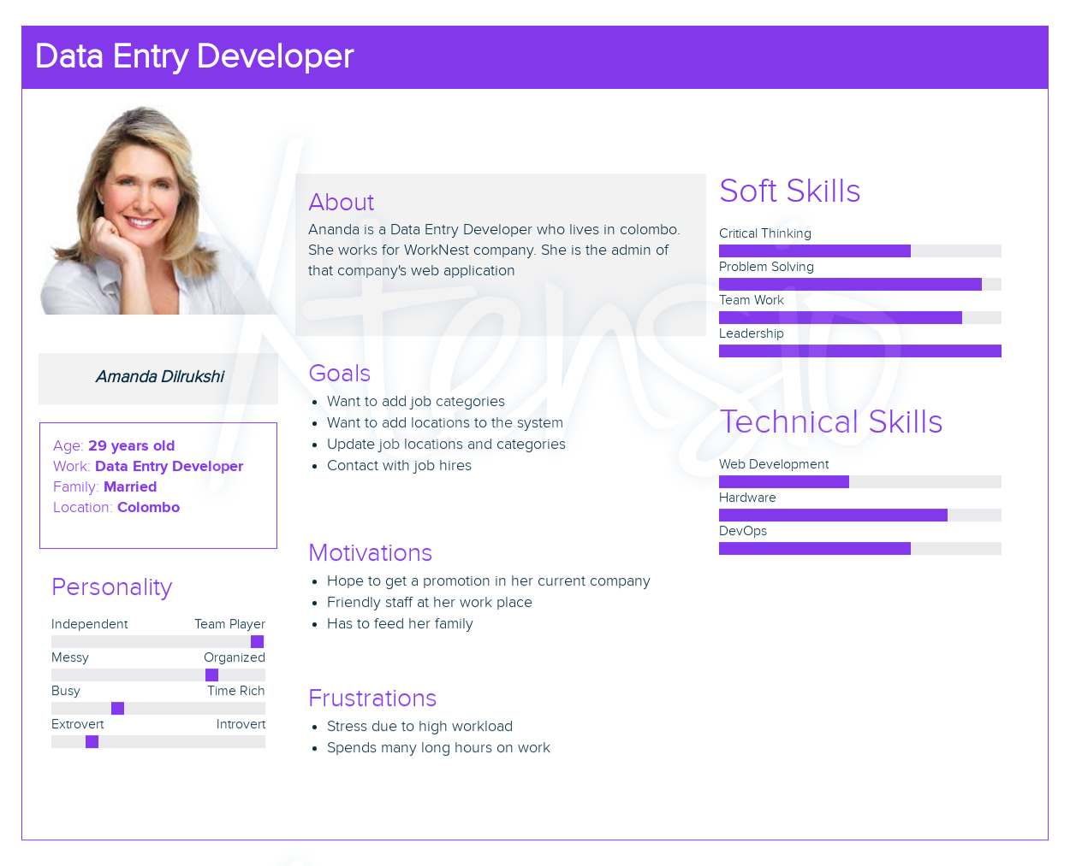

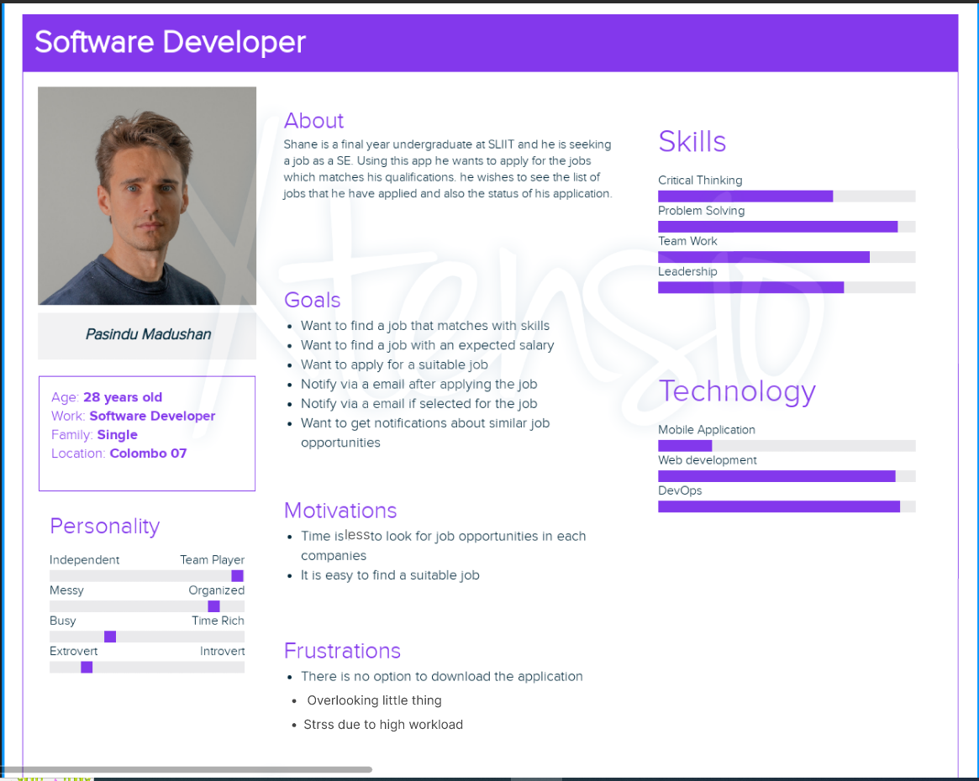

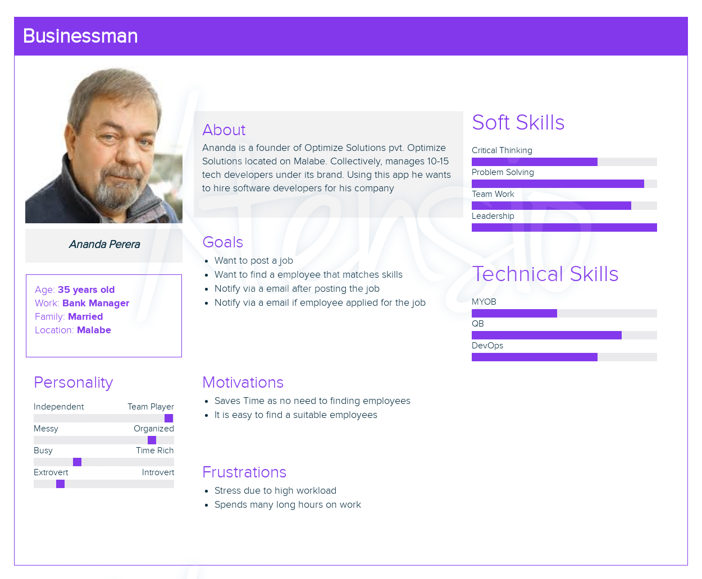

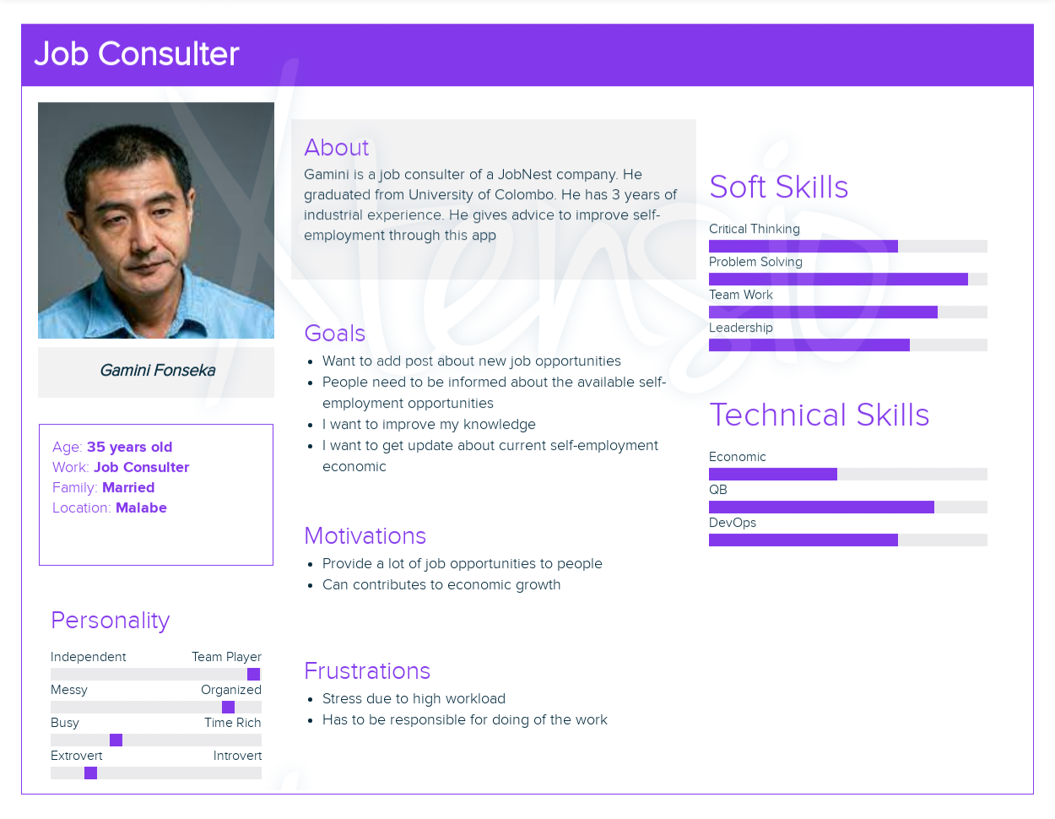

## Empathy map(s) – 04 Empathy maps from a group

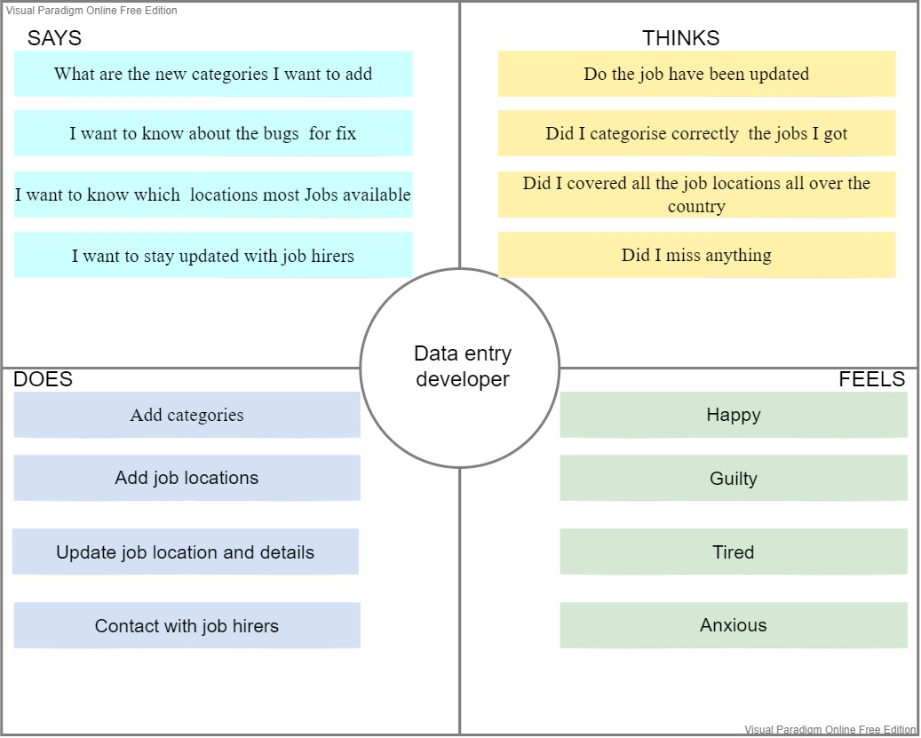

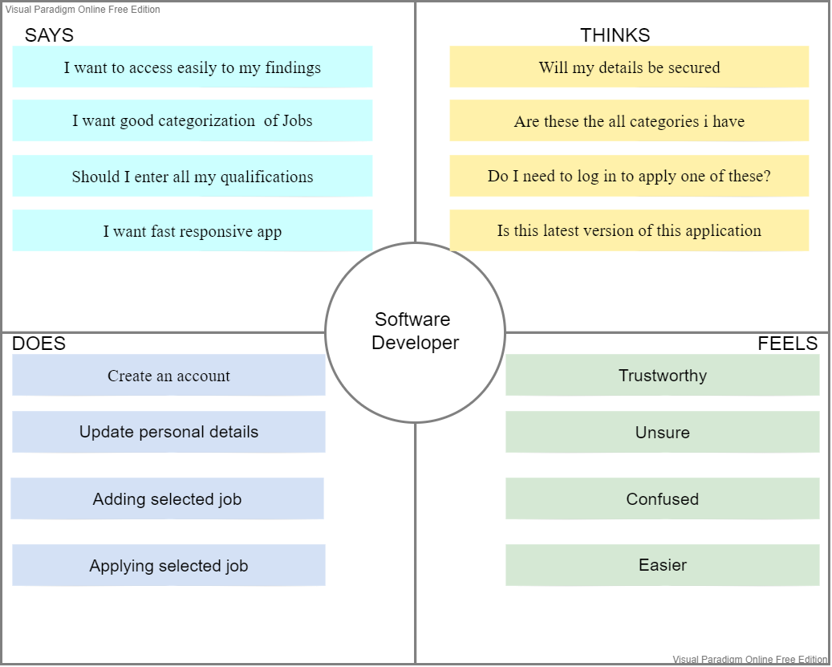

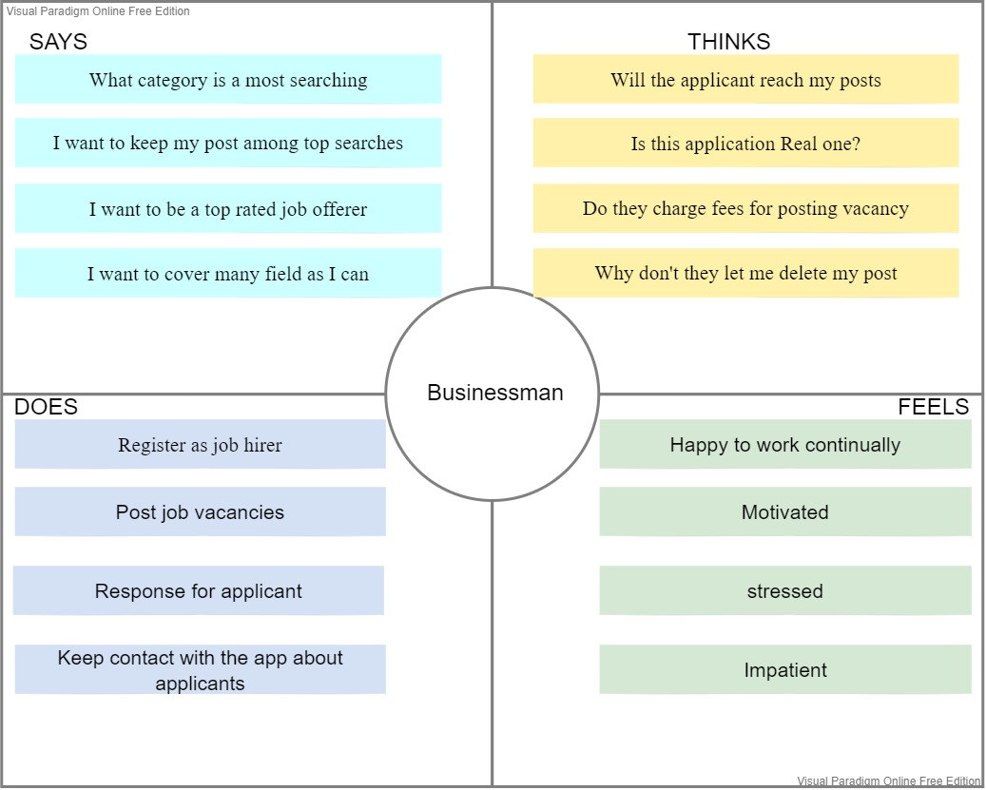

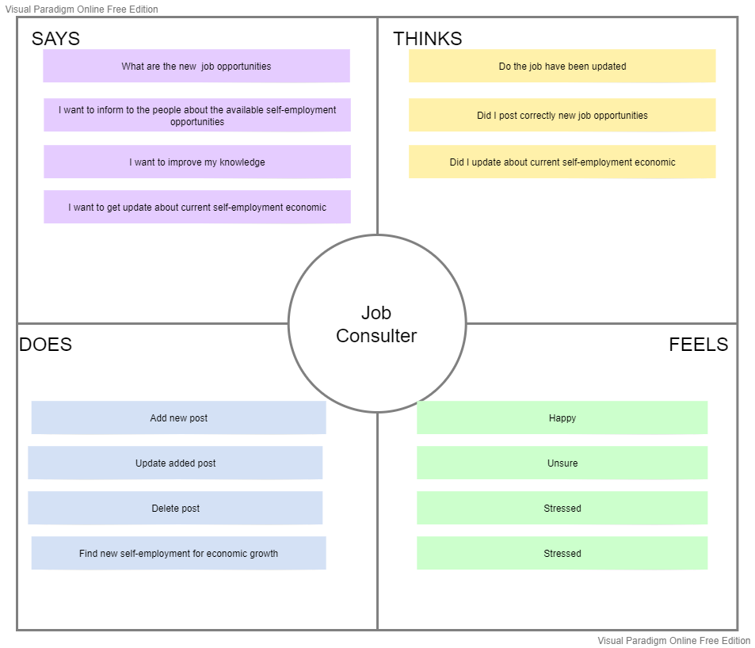

## User stories – 04 User stories from a group

1. As an admin,

I want to add categories into the system,

So that user will be able to search jobs from categorized list.

1. As a registered job seeker,

I want to find suitable job information and apply for jobs

So that I can find a suitable job for my qualifications.

1. As a registered job hiring man,

I want to add job post to the system,

So that job seeker will be able to apply for the job.

1. As a consulter,

I want to inform to people about the available self-employment opportunities

So that I can contributes to economic growth.

## User flow(s) - 04 User flows from a group

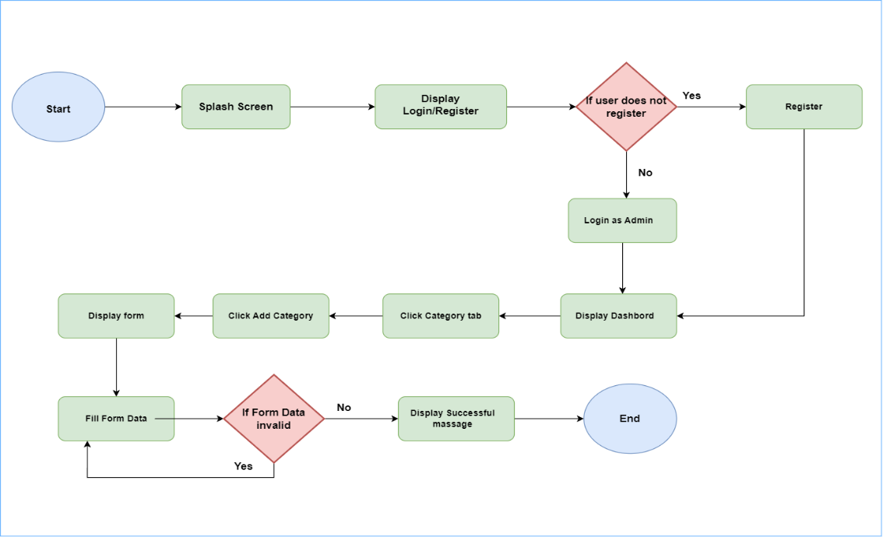

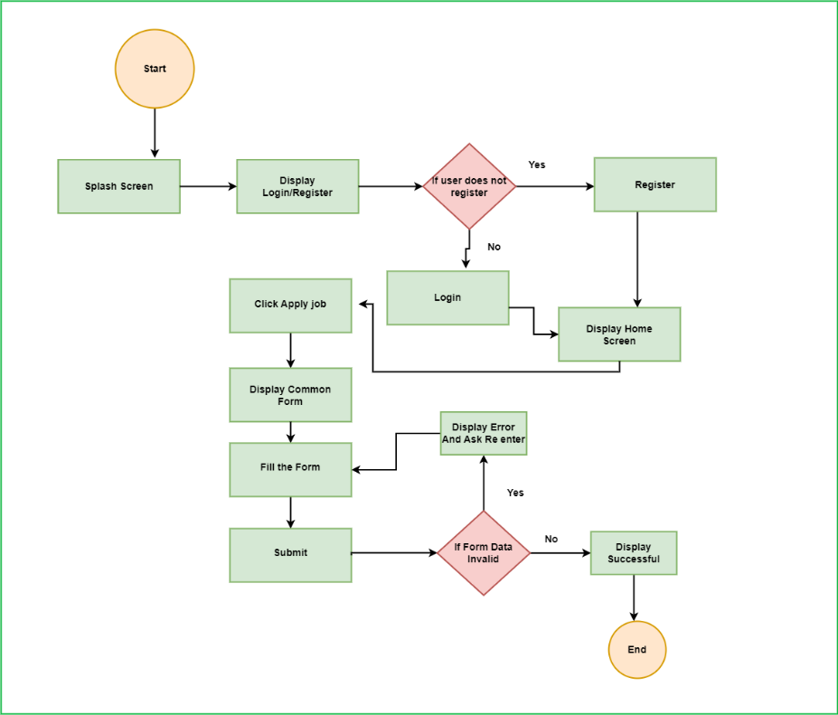

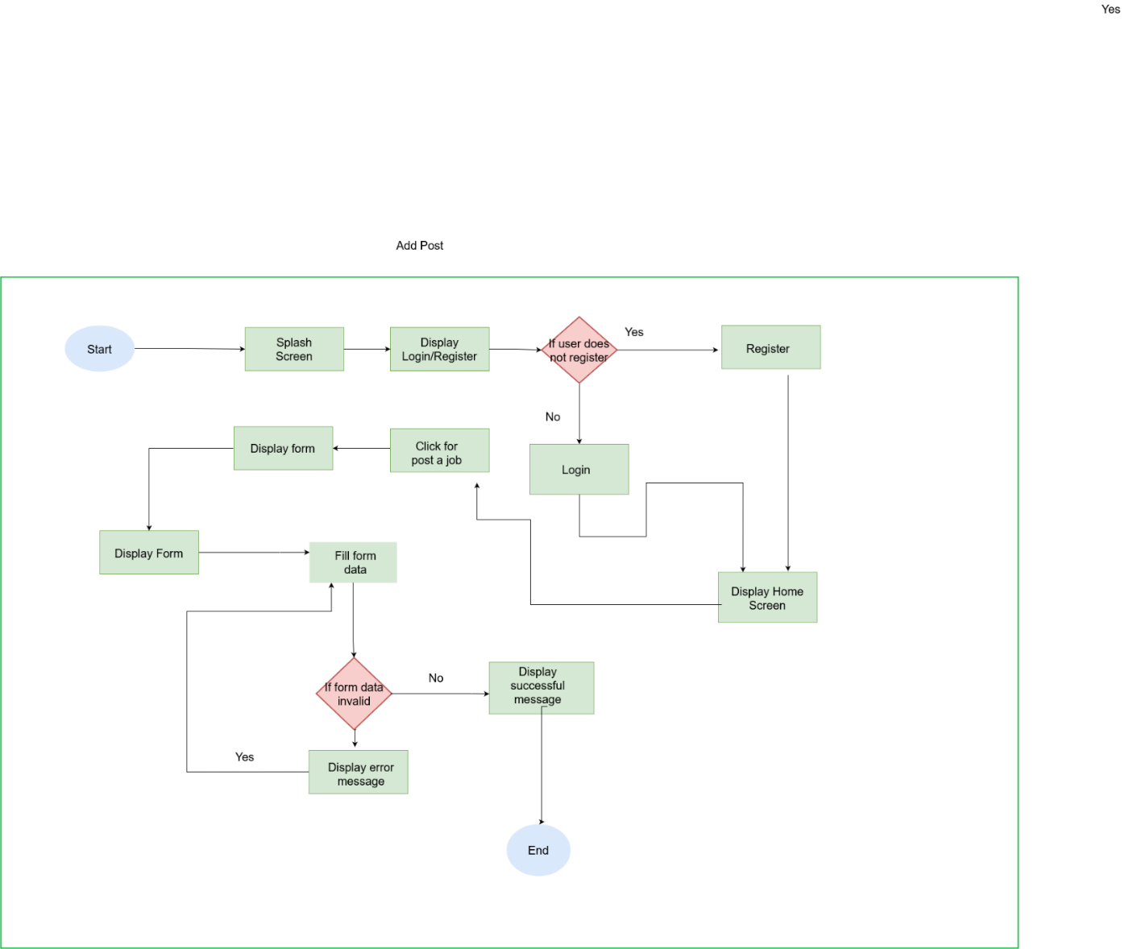

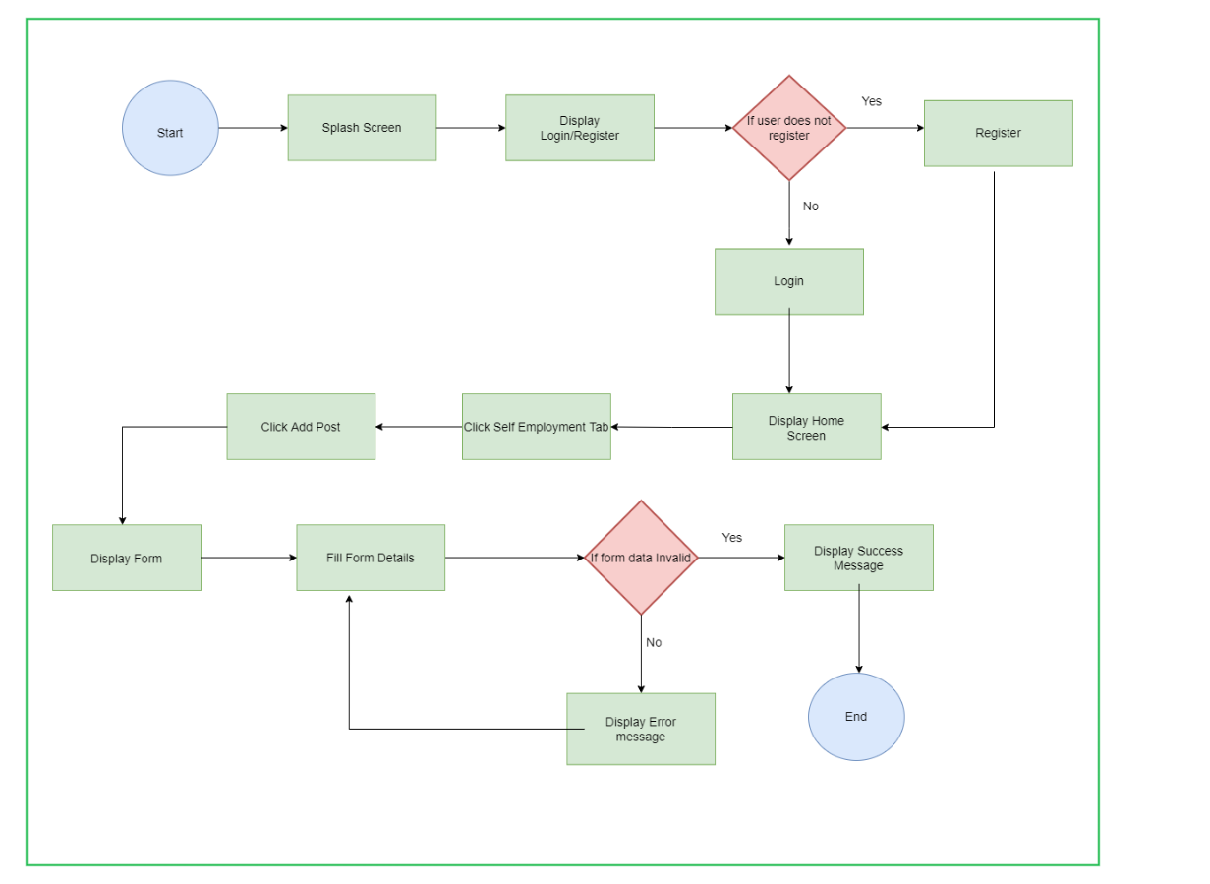

## Service Blueprint(s) – 01 Service Blueprint from a group

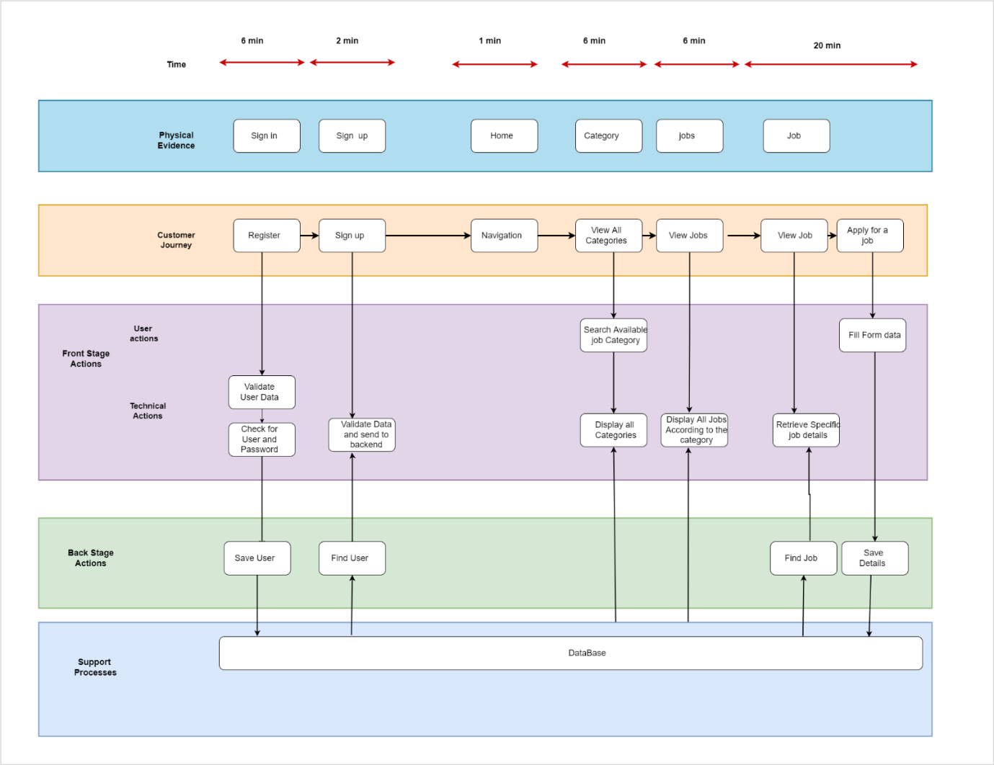

# Milestone 2: Plan and conduct user research

**Introduction**

The app that is tested for reducing unemployment for economic growth. The app is developed by job nest pvt and offer a lot of functionalities. Mainly the app allows to find a job for users and allows to post job advertisements for job provider. Furthermore, users can search jobs under job categories, and they can view relevant jobs. Although it offers a lot of functionality from a user's perspective, there are a lot of shortcomings in the application itself when it comes to interface design and user experience in the following sections, we will discuss the usability testing process that was done to pinpoint those short comings, thus gathering the necessary information to improve the quality of the redesigned product.

The following objectives were focused when conducting the usability test.

* Identify key features of the application that proposed
* Identify different user expectations and different viewpoints
* Identify the technical knowledge of the of different user groups
* Identify the limitations of the users
* Identify the challenges that we must face
* Identify the technologies that can be used to build the application
* Identify the resource limitations
* Identify the additional features that we should include according to the gathered requirements
* Identify fulfilment of all specified requirements

The above-mentioned areas will be mainly focused when usability testing

**Goals**

The goal of the Unemployment research is that ensure the requirements of as a receiver for this application. we took the self-employment, apply job opportunities, posting job vacancies, consult for the economic growth. those are the main goals, and we need to clarify those requirements.

IT20642914 – Gamage B.G.A.C

The goal of the user research is that ensure the requirements of the date entry developer for this application. He wants to add job categories and add locations to the system. We gathered information via the google form from users. We ask about fields that they interested in to work. According to their answers we were able to get better idea about categorization of job opportunities according to the different fields. As well as data entry developer can update job categories and locations according to the job provider’s requests.

IT20641092 -Wijesinha W.S.S.

The goal of the user research is that ensure the requirements of the job seeker for this application. He wants to find a job that matches with his skills and his expected salary. As well as he wants to apply for a suitable job type. We gathered information about their salary range and what they willing to do for increase their income. Such as full time, part time, remote jobs, and self-employment. According to the gathered information we noticed users wants to get notifications about similar job opportunities.

IT20637064 – Anuththara R.M.C

The goal of the user research is that ensure the requirements of the job consulter for this application. He wants to share about self-employment new job opportunities. He wants to consult to the peoples for getting start with self-employment and he wants to consult for economic growth. For that we collect some suggestions from users via google form

IT20639662 – Navodi P.T

The goal of the user research is that ensure the requirements of the Job poster for this application. He wants to hire an employee that matches with skills as well as he wants to get notify after he is posting job vacancy. Also, he wants to get notify if employee applied for the job. We gathered new suggestions to improve the proposed app

**Research Questions**

IT20642914 – Gamage B.G.A.C

* What are the expectations of the Data entry developer from this app?
* Did user have previous experiences
* Do all the features are required or not?
* Can they handle every feature in single application?
* Currently how do they manage the work?

IT20641092 -Wijesinha W.S.S.

* Identify different user categories as a job seeker
* Did user have previous experience with a similar app
* Did user face difficulties with that application?
* What are the suggestions for ease job applying process?
* What qualities that the user expect form the app when using?

IT20637064 – Anuththara R.M.C

* Did user have any idea how can start a self-employment
* Did the user have previous experience in self-employment?
* Did user expect to consult from consulter for a self-employment
* What features is the app going to need?
* What is the opinion on meeting the consultant via the app?

IT20639662 – Navodi P.T

* Did user wish to prioritise the agent job vacancies.
* What are the suggestions to improve the proposed app
* Did user like to filter job categories when posting jobs
* How do users feel about a mobile application?
* What features the user expecting from this proposed app

**Methodology**

For the user study, we carried out questionaries and interviews with relevant people according to the personas and we were able to identify pain spots and test the hypothesis.

User interviews and comments obtained using a shared Google form were the approaches for user experience research that were selected. When compared to expensive methods like ethnographic field research or usability lab studies, which were either much more expensive or time-consuming, these techniques were economical, accessible, and efficient.

**Interviewing**

* The objective was mainly to get an understanding about users that we target to use the application and identify the issues
* To do that a script was prepared covering all aspects of the functionalities that we are expecting to include in our system.
* Interviews were conducted online using the physically and moderated by team members by themselves

**Data Entry Developer** (**IT20642914)**

**--Questions to get an understanding of the user demography**

* First of all, tell us bit about yourself

* Have you worked as Data Entry Developer?

* Can you describe your experience?

* Did you faced any difficulties when you work as a data entry developer?

**--Questions to understand how the user thinks about the process as a Data Entry Developer**

* Why are you interested in this role?

**--Questions to an understanding about how the user think about Data entry developer process using an app**

*Do you have any idea about job classification?

* As a Data entry developer, what are the qualities do you need for this application?

* What kind of process do you expect from our application?

* What method do you prefer to provide your service? For example, to serve via, hybrid or physical?

* Finally, do you have any suggestions for our app?

**Job Seeker (IT20641092)**

**--Welcome the user**

* Good afternoon Mr. Chandima I am Sachini from 3rd year 1st semester of faculty of computing of SLIIT and before I begin, I have some information for you.
* We are going to develop an application to find and applying jobs via online and we are testing the usability of this application and we are using these details only for our academic purpose.
* Here we are asking your thoughts and suggestions and we like to see how this application reacts when you are performing the tasks.
* So, Mr. Chandima, Are you OK with this, or else if you have any questions, you can ask

**--Questions to get an understanding of the user demography**

* So, Mr. chandima, I would like to know a bit about yourself?
* What is the employment status of yours?
* What are the job fields that you interested in working?

**--Questions to understand how the user thinks about the process of finding and applying jobs via app**

* What are the methods that you used to find jobs?
* Do you have any experience in using online platform for finding jobs and applying for those jobs?
* How about that experience?
* What method do you prefer as the best for finding and applying jobs?
* Did you faced any difficulties when finding and applying a job via an app?
* what are the qualities you expect from an app for finding and applying jobs?
* Finally, do you have any suggestions for our application?

**--Thanks to the user**

**Job Consulter (IT20637064)**

**--Welcome the user**

**--Questions to get an understanding of the user demography**

* Hi Kavindu, can you please give me a brief introduction about yourself?

* So, have you got any prior work experience as a consultant?

* Ok great. How long have you been working as a consultant?

* How did you give consultancy? Via online sessions or did you have face to face Consultancies?

**--Questions to understand how the user thinks about the process as a job consulter**

* Why are you interested in this role?

**--Questions to an understanding about how the user think about Job consulter process using an app**

* As a Job consulter, what are the qualities do you need for this application?

* What kind of process do you expect from our application?

* What method do you prefer to provide your service? For example, to serve via, hybrid or physical?

* Do you know what type of an app is this and what type of consultancy that you must provide to the requested users?

* How to motivate self-employed?

* How do you work for economic growth via this application?

* Finally, do you have any suggestions for our app?

**--Thanks to the user**

Ok Mr. Kavindu Thank you for giving your valuable time and share your ideas with us. Have a nice day.

**Job Poster (IT20639662)**

**--Welcome the user**

* Good afternoon Ms. Oshini I am Tharushika from 3rd year 1st semester of faculty of computing of SLIIT and before I begin, I have some information for you.
* We are going to develop an application to find and applying jobs via online and we are testing the usability of this application and we are using these details only for our academic purpose.
* Here we are asking your thoughts and suggestions and we like to see how this application reacts when you are performing the tasks.
* So, Ms. Oshiji, Are you OK with this, or else if you have any questions, you can ask

**--Questions to get an understanding of the user demography**

* So, Ms. Oshini, I would like to know a bit about yourself?
* What services or products do you offer?
* What qualities do you look for in new employees?

**--Questions to understand how the user thinks about the process of finding and applying jobs via app**

* How did you know about job next application?
* Do you have any experience in using online platform for post your job advertisement?
* As a job poster what are the experience you get from the application? (Good or bad)
* Did you wish to prioritize the agent job vacancies that you post?
* Did you want to have cv count for each job vacancies posted by you?
* Finally, I want to know,

what are the suggestions to improve the proposed application?

**--Thanks to the user**

## **Video Recording links:**

<https://mysliit-my.sharepoint.com/:f:/g/personal/it20642914_my_sliit_lk/EqCQm_5rELJAo98IE5VeEFgBysgZxkAPnkGyOPQ8abEH1Q?e=XCLNiK>

**Questionnaire**

Google Form Link: <https://docs.google.com/forms/d/e/1FAIpQLSdAZY1q_xIBcTzhaqGcI7OKX5RtH2OlGF2T8H2ITxbyZ59FPQ/viewform?usp=sf_link>

**Questions & Responses**

The questionnaire is divided into 4 sections

The first section contains questions to get a demography of the user

**Demographic questions**

* To get an understanding about the user’s demography questions such as
  + - Age group
    - Employment Status
    - Monthly income

**Section on Self-Employment**

* In this section mostly questions regarding the self-employment
* Also get advice from consultant how they can start or improve self-employment

**Section on Job Applying**

* In this section mostly questions regarding problems user faced when they are applying for the job
* Also get suggestions to ease job apply process

**Section on Job Posting**

* In this section mostly questions regarding problems user faced when posting a job
* Also get suggestions to ease job posting process

**How the questionnaire should be distributed and data collection process?**

* The questionnaire will be distributed online since Google Forms was used to create it.
* WhatsApp groups will be used as the primary distribution channel.
* Online forums will also be used for data collection.

**Questions & Responses**

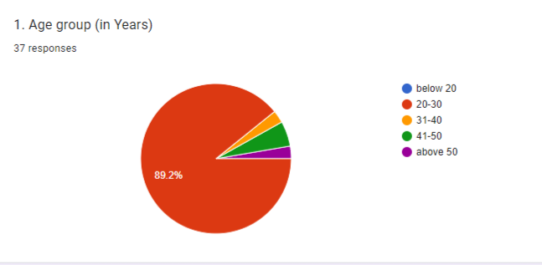

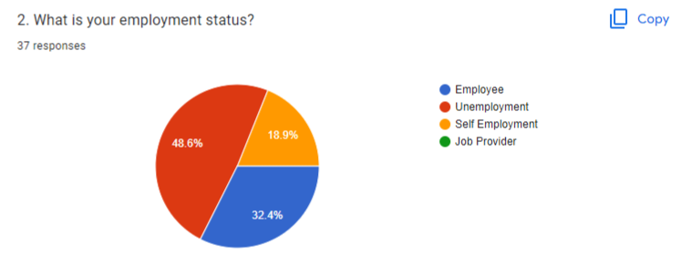

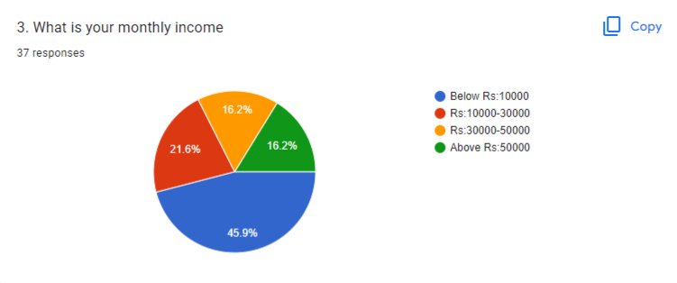

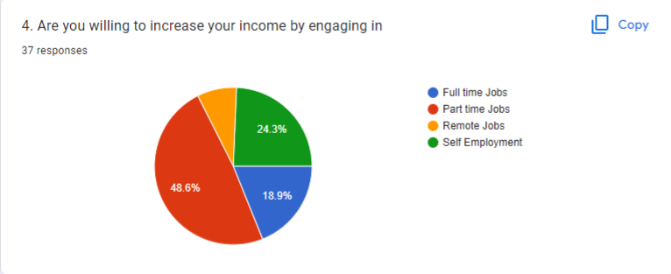

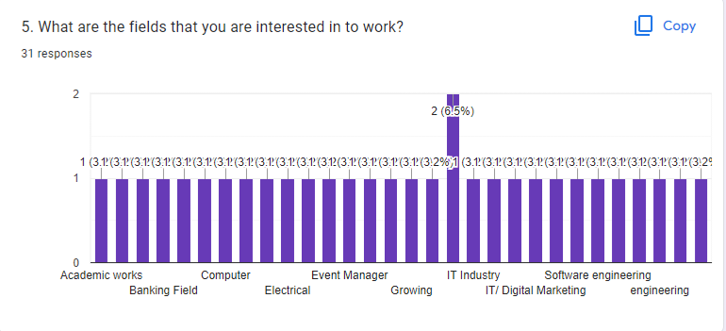

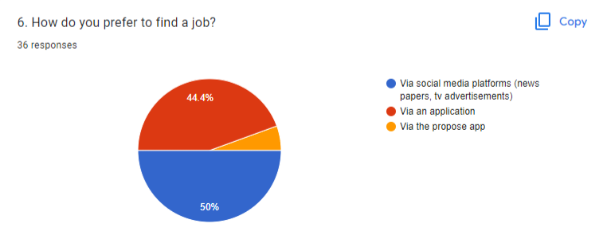

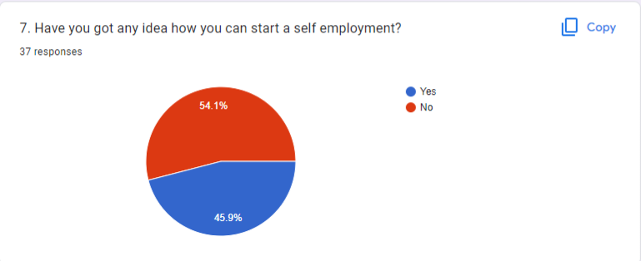

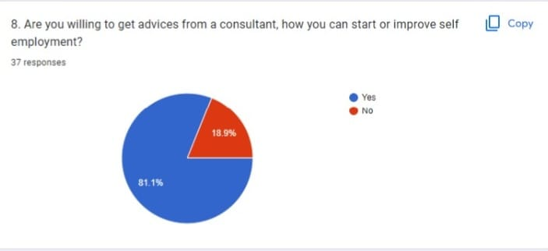

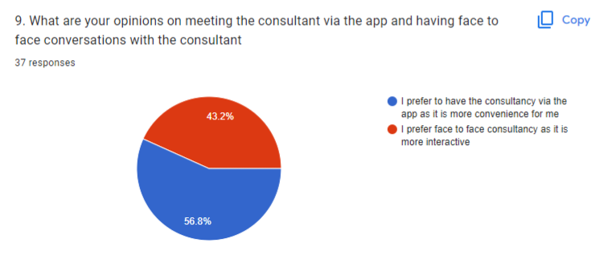

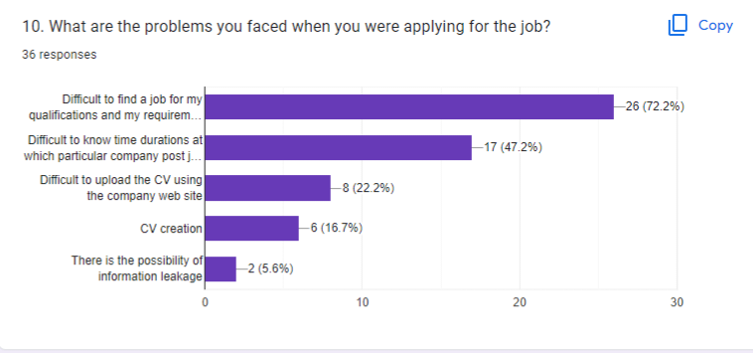

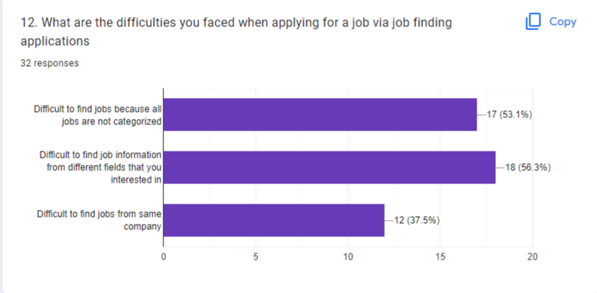

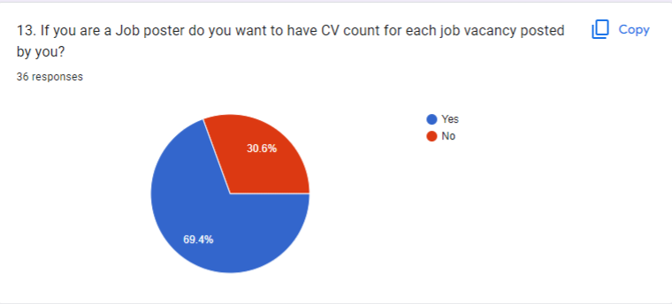

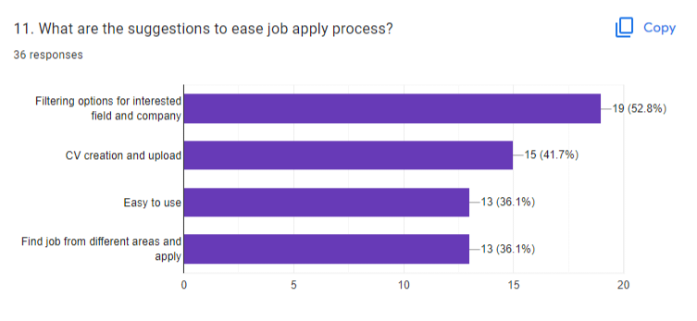

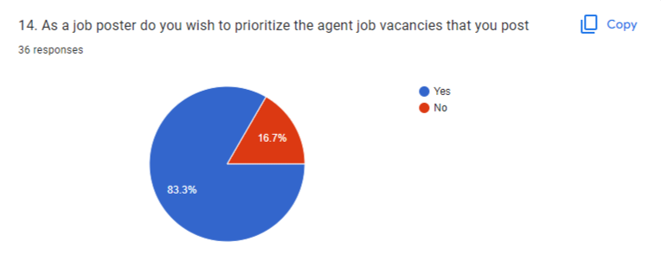

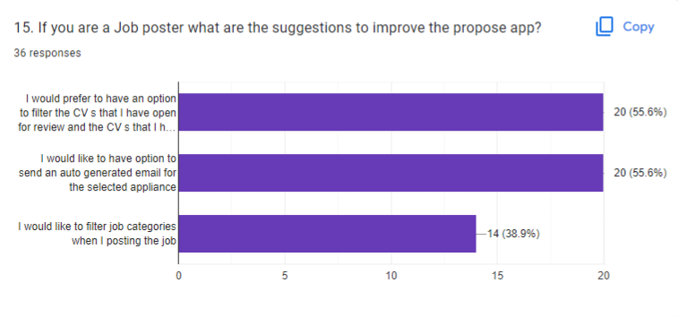

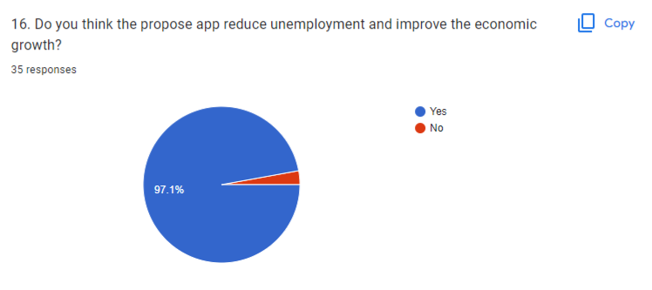

**Participants**

|  |  |  |  |
| --- | --- | --- | --- |
| **Interviewee Name** | **Demography** | **Location, Date and Time** | **Interviewer Name** |
| Ms.R.C.P Rajapaksha | Age: 26  Gender: Male  Marital Status: Single  Location: Colombo  Profession: Data Entry Developer | Location: Colombo  Date: 26/09/2022  Time: 4.00pm | **IT20642914 – Gamage B.G.A.C** |
| Mr.Chanadima sooriya arachchi | Age: 23  Gender: Male  Marital Status: Single  Location: Colombo  Profession: software developer (as a job seeker) | Location: Colombo  Date: 26/09/2022  Time: 2.00pm | **IT20641092 -Wijesinha W.S.S.** |
| Mr. Kavindu | Age: 28  Gender: Male  Marital Status: Single  Location: Colombo  Profession: Job Consultant | Location: Baththaramulla  Date: 26/09/2022  Time: 2.00pm | **IT20637064 – Anuththara R.M.C** |
| Ms.Oshini | Age: 25  Gender: Female  Marital Status: Single  Location: Colombo  Profession: Job provider | Location: Baththaramulla  Date: 26/09/2022  Time: 3.00pm | **IT20639662 – Navodi P.T** |

**Protocol**

The questionnaire is planned to be distributed online since it was created using google forms

● The main method that we used to share it through WhatsApp groups

● Also, other social media platforms such as Facebook and Instagram are planned to be used

● One other method of data collection is online forums

* We went to meet the Interviewee physically.
* Then we show the user flow and gave a brief introduction to our system.
* Check Interviewee technical knowledge related to our app
* Then get any suggestions from the Interviewee for the app features.

# 

# Milestone 3: Verify the key-user flow(s)

|  |
| --- |
| Fail Point/Blocking |
| 1)admin cannot register him self   |
| 2) does not include if logging failed part   |
| 3) Admin should redirect category tab after successful adding   |

**before**

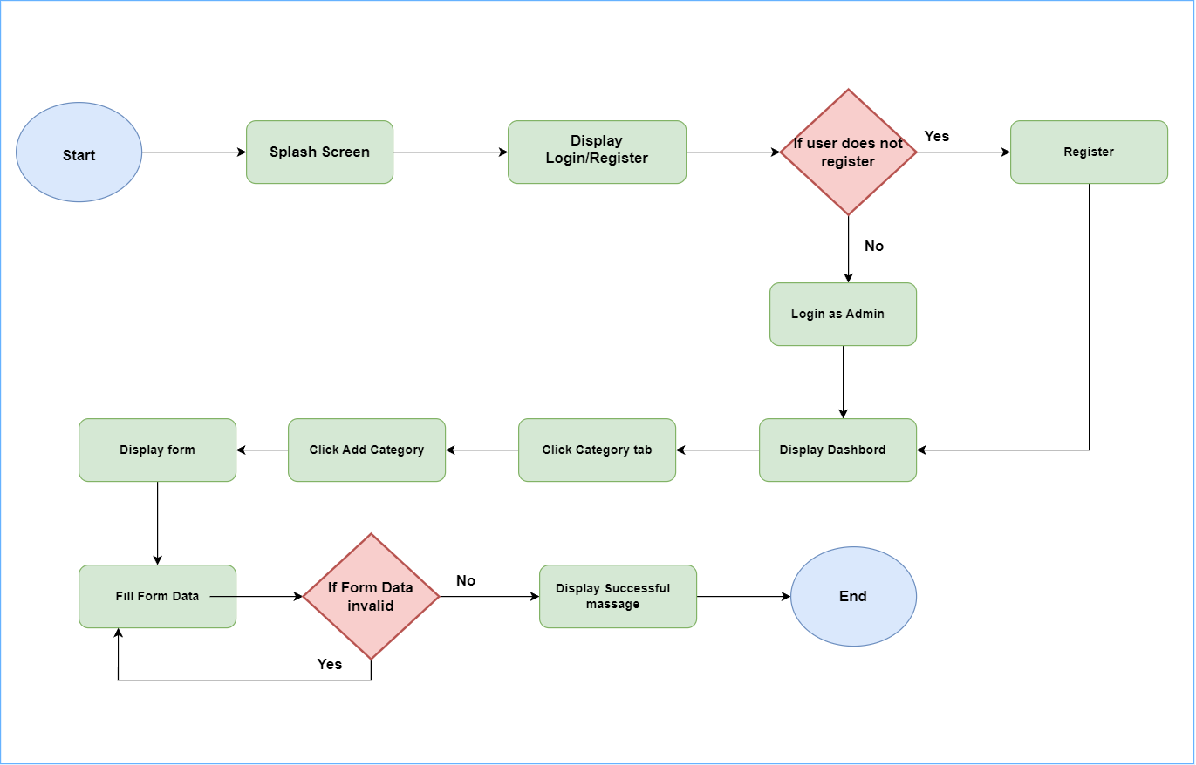

After fixing

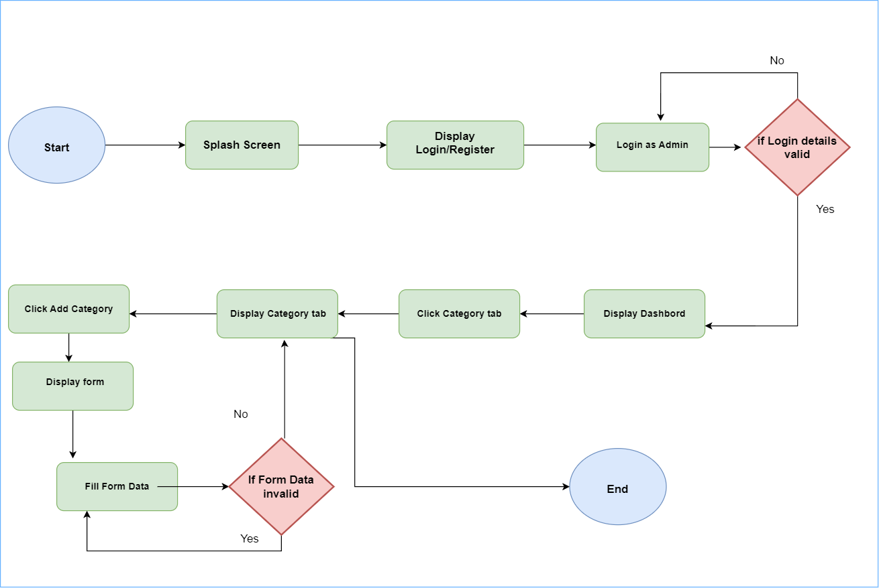

2nd user flow

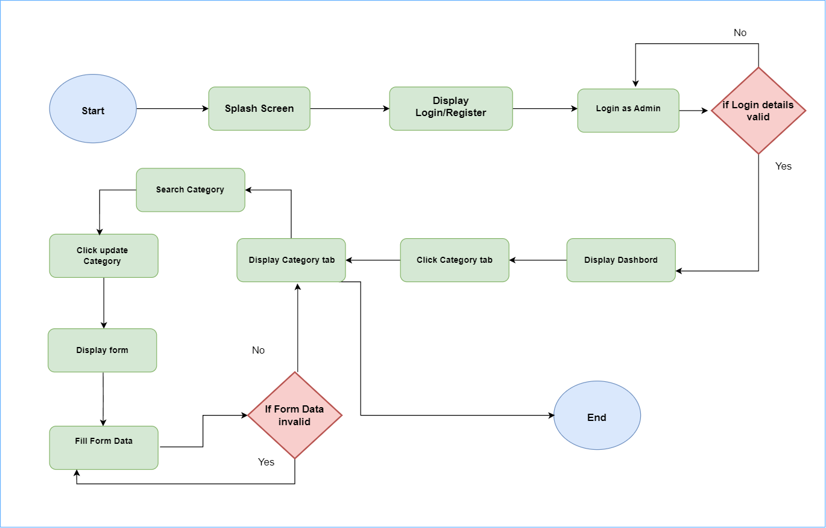

User flow 3

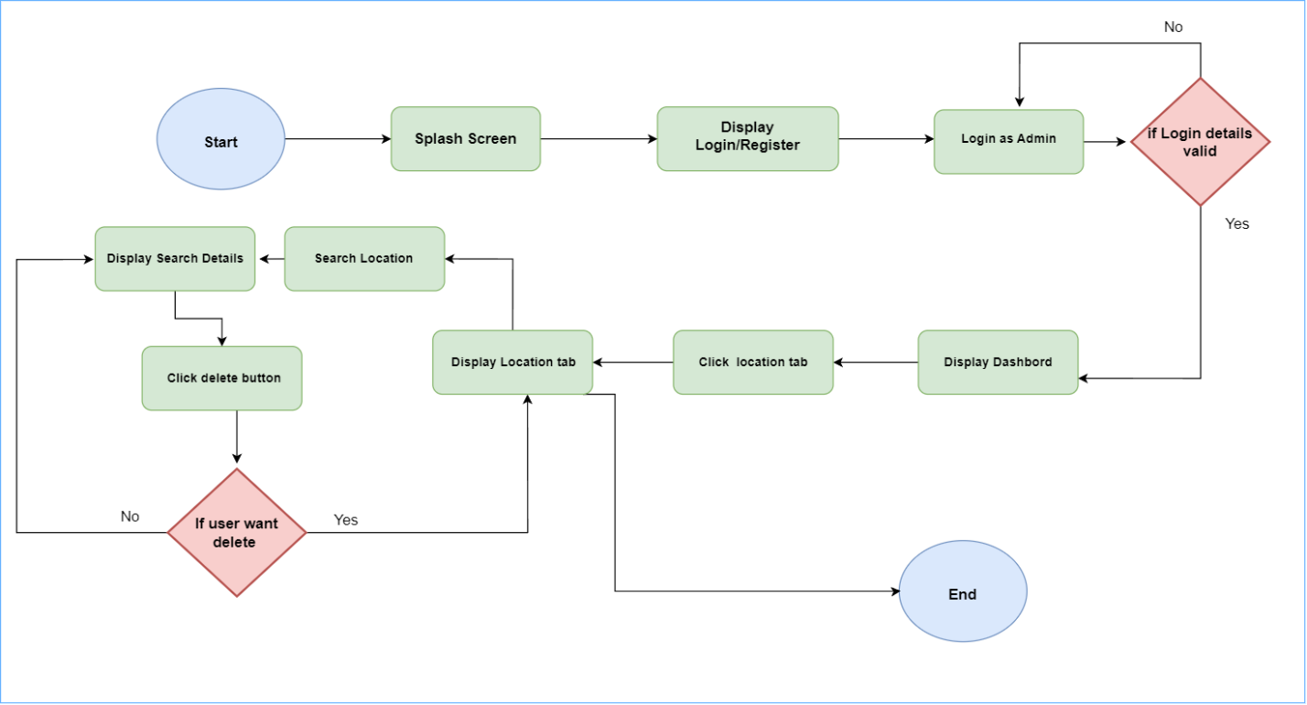

|  |
| --- |
| **Fail Points /Blocking** |
| 1. Does not include the part of, choosing login roll and login     Diagram  Description automatically generated  Diagram  Description automatically generated  This will allow user to log in as job seeker   1. Does not include validations and Loop   Diagram  Description automatically generated    Diagram  Description automatically generated    user have to re enter details again and again until login details become true   1. User wanted to see jobs in categories so that he/she can find jobs easily   Diagram  Description automatically generated    Diagram  Description automatically generated |

**Before Re-correcting**

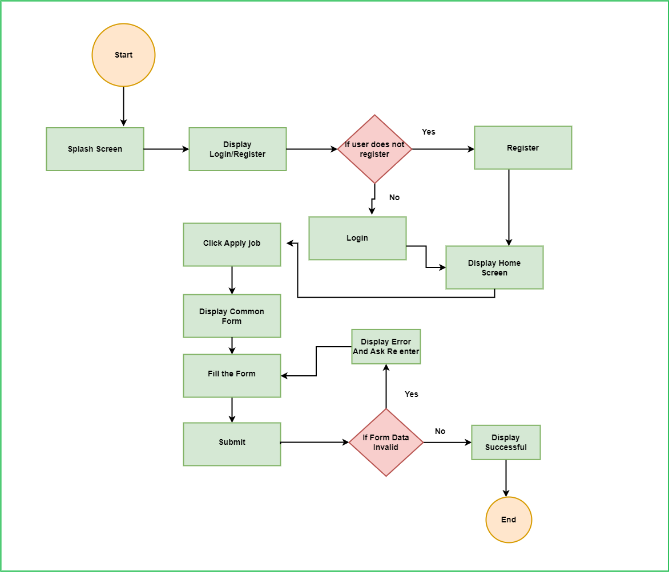

**Corrected**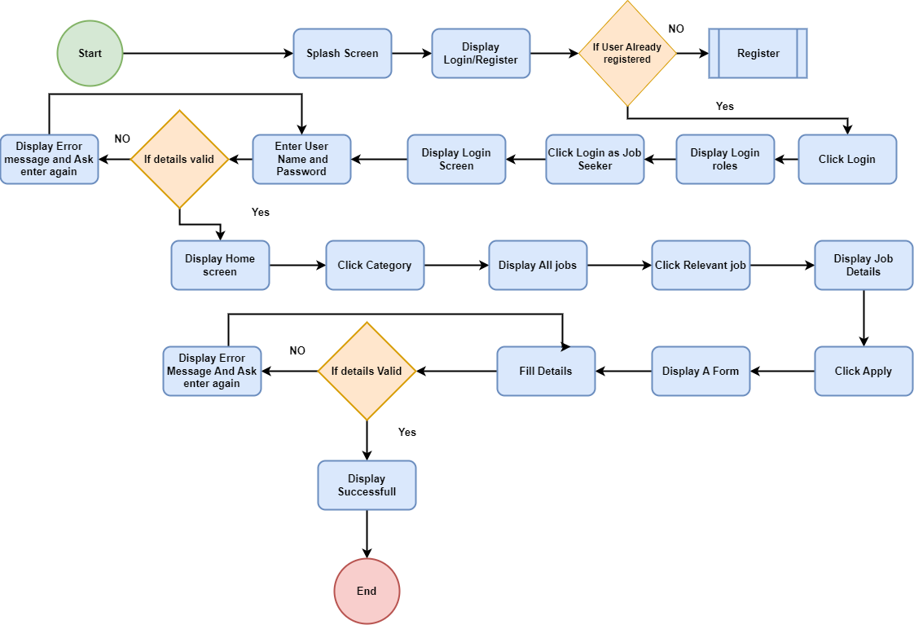

**User flow 1**

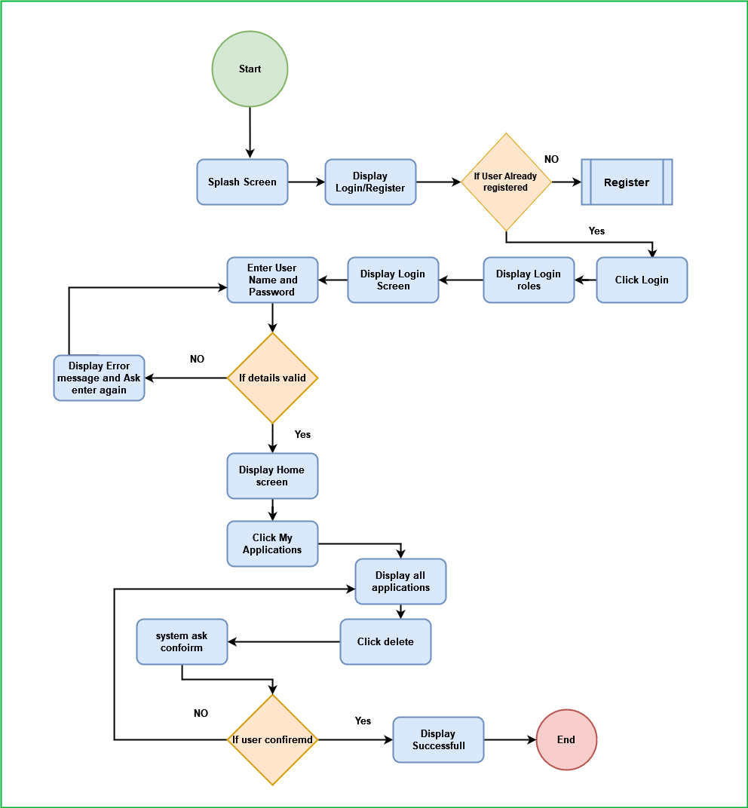

**Flow 2**

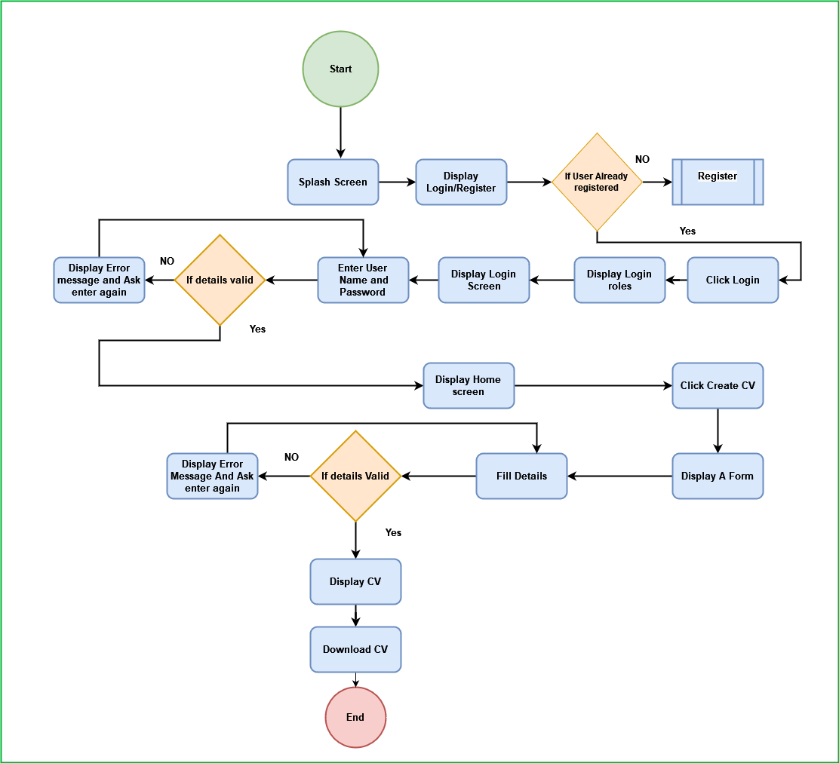

**IT20637064 - R.M.C Anuththara**

|  |
| --- |
| Fail Point/Blocking |
| 1) Admin can’t register his profile by himself. She/he can log in an existing account. If the login credentials are incorrect she/he will redirect to the login page  Diagram  Description automatically generated  Diagram  Description automatically generated |

|  |
| --- |
| 2) After the filling post form there should button for submit  Diagram  Description automatically generated  Diagram  Description automatically generated  3.If an error message displayed then the user will be redirected to Form  BEFORE  Diagram  Description automatically generated  AFTER  Diagram, schematic  Description automatically generated |

|  |
| --- |
| existing flow chart for posting self-employment post  Diagram  Description automatically generated  After fixing errors  Diagram  Description automatically generated  2nd User Flow  Diagram, schematic  Description automatically generated  3rd User Flow  Diagram  Description automatically generated  Fail Point/Blocking    1)Login issues (Does not include the login validation)    2)Register issue (Does not include the register validation)    **Before fixing errors**    **After fixing errors**  **2nd User flow**- Update post    No  Yes  **3rd User flow** – Delete post |

# Competitor Analysis

In the UX research process, competitive analysis is essential. It is crucial to look at existing solutions for our problem statement before launching a product or service. Competitive analysis reveals the features given by competing solution providers in the industry where our app operates that are effective and ineffective.

It aids in our strategic creation of an exceptional experience that makes our goods stand out.

## Competitor 1

## Advantage

* Affordable - courses are affordable, starting at $11.99 and go up to $199.99.
* Free Courses - offer close to 600 free courses on a selection of topics from word press to fitness.
* 30-day Refund Policy - If the course wasn’t what you expected, Udemy will give your money back no questions asked.
* Lifetime Access - Udemy will grant you access to every course you’ve purchased for life.
* Wide selection of courses - Offering more than 204K+ on 13 of categories and dozens of sub-categories. You really will be spoiled for choice.

## Disadvantage

* Big cut from the revenue
* Have to be on Udemy from early
* Ownership Issues
* Advertisement Trap
* Lack of Design Flexibility
* Doesn't create course content - With Udemy the course instructors are responsible for creating its content which can impact the quality of the course.

## Translation

* In our application, users can view course content to get an idea about the courses.

## Competitor 2

# Milestone 4: Sketching

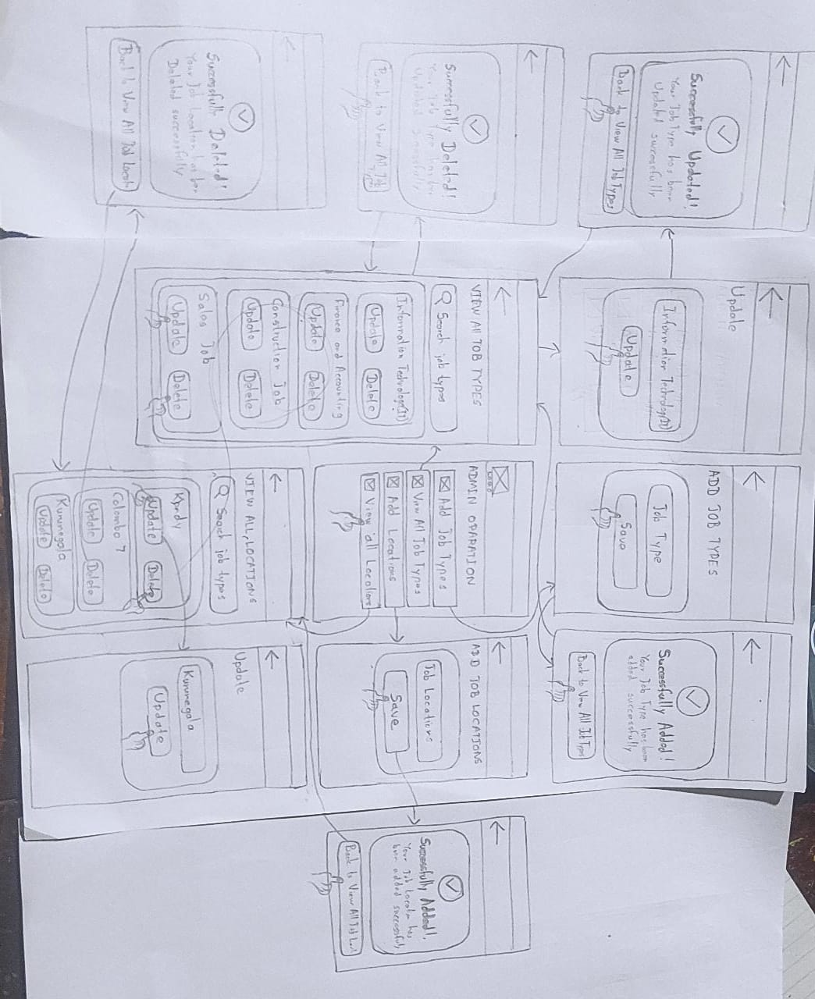

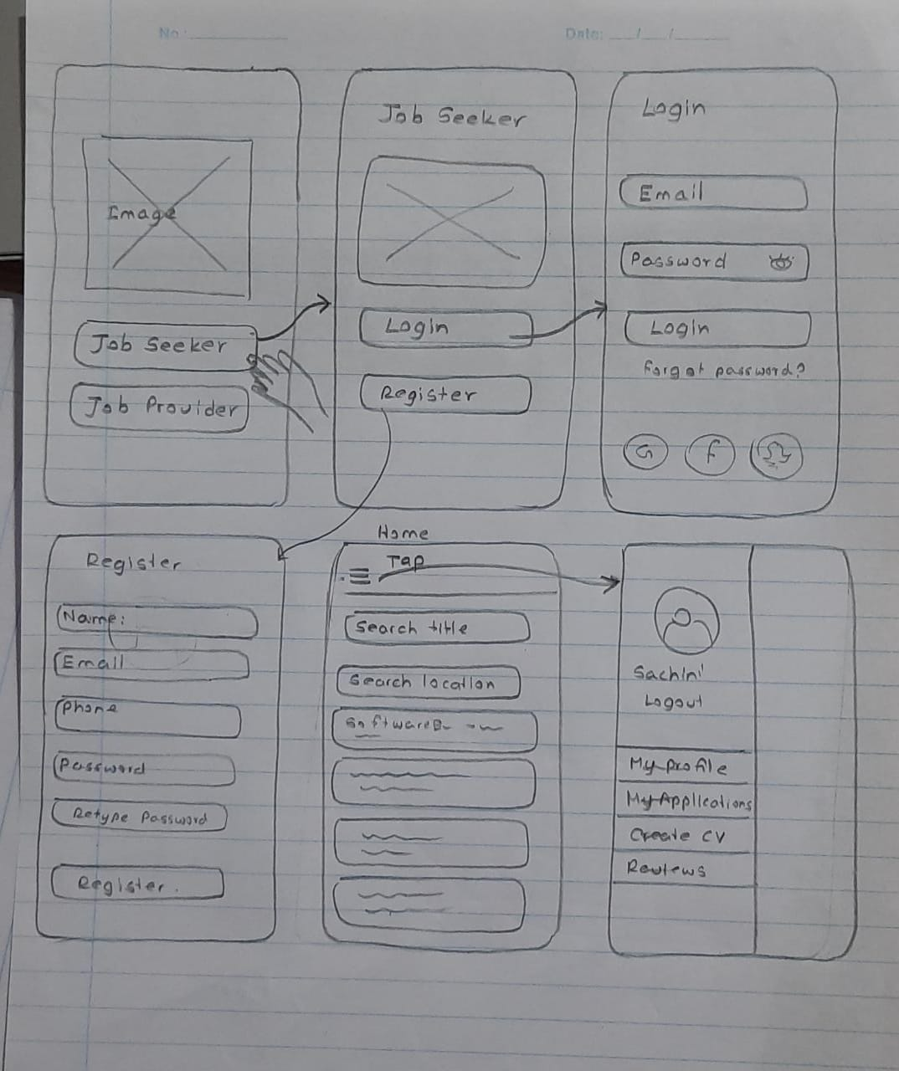

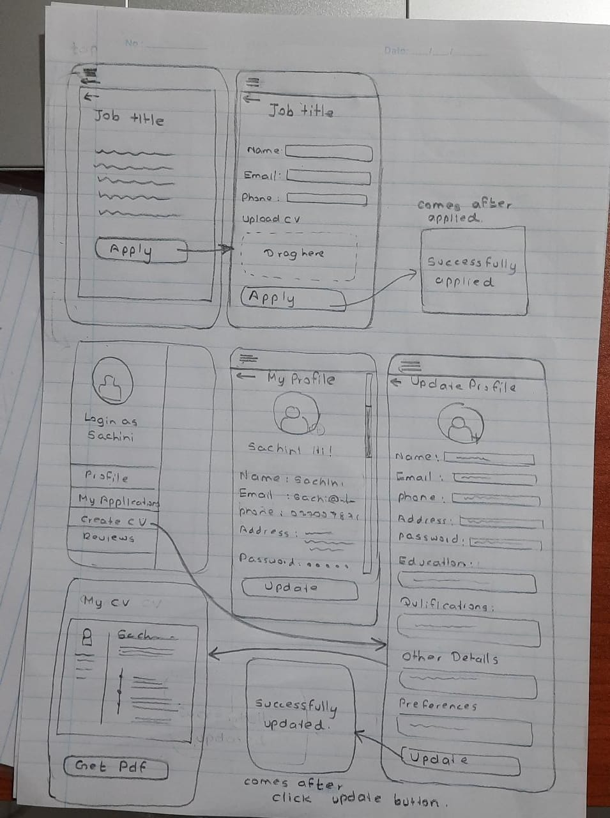

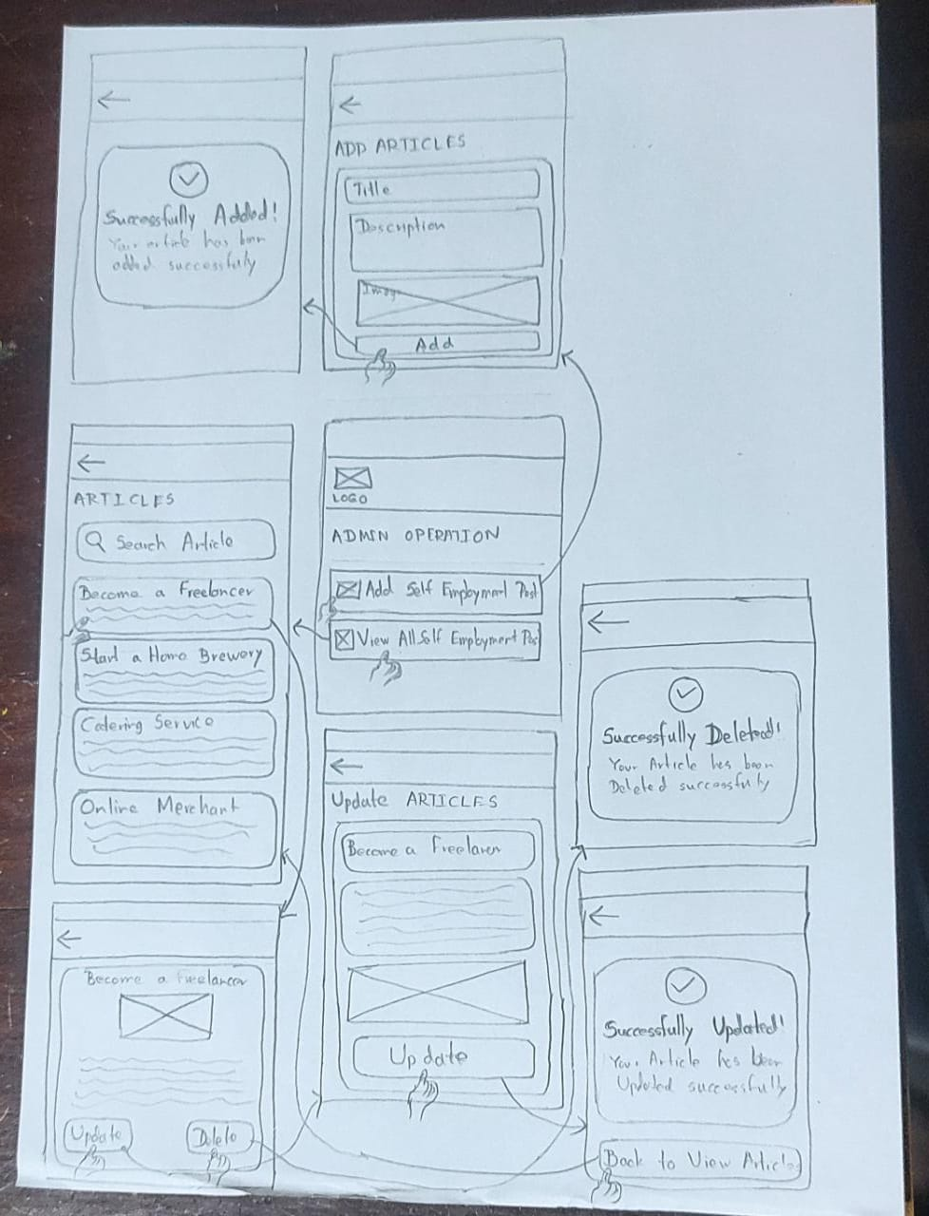

# Milestone 5: Wireframes, Prototype

This is where you showcase all the prototypes (low-fidelity and high-fidelity). Include as many significant low-fidelity designs as you developed. i.e. links to your Figma website.

## 8.1 Low-fidelity Wireframes

**Member 1 -** **IT20642914 (Gamage B.G.A.C)**

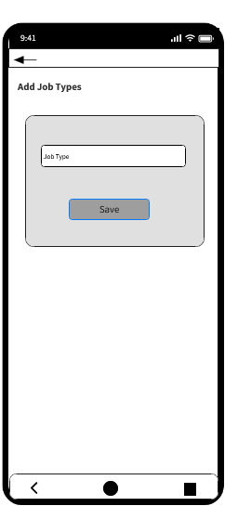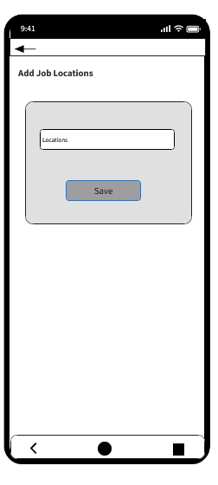

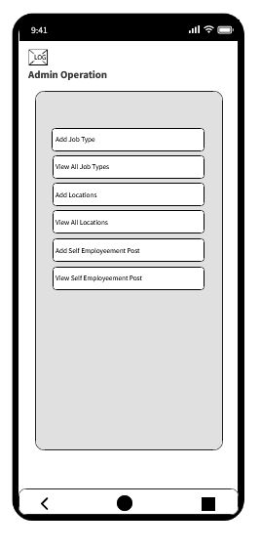

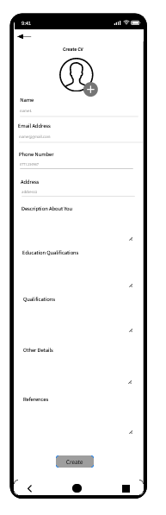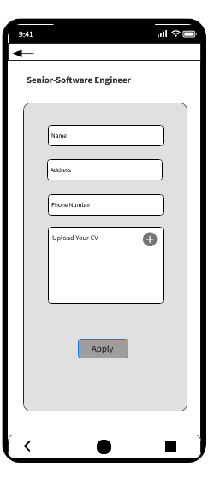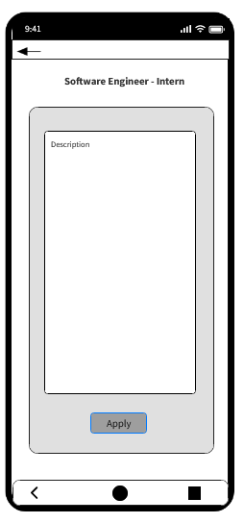**Member 2 - IT20641092(W.S.S Wijesinha)**

**Member 3 - IT20637064 (R.M.C Anuththara)**

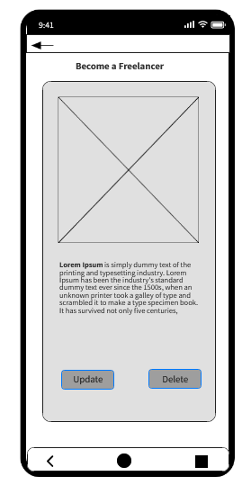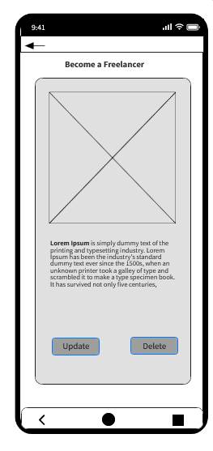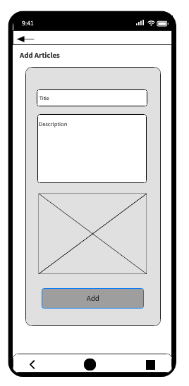

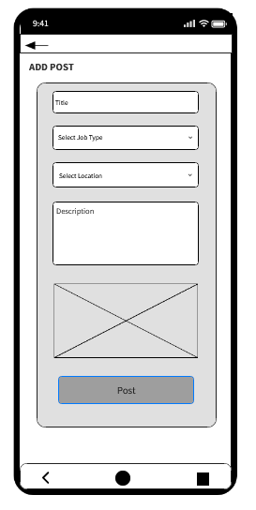**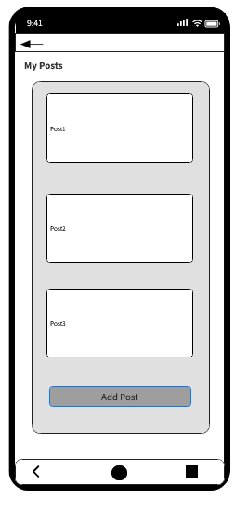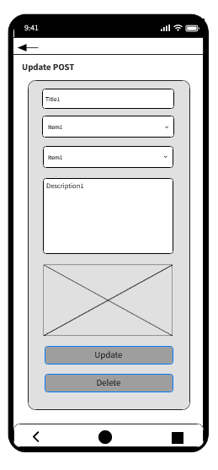Member 4 _IT20639662 (Navodi P.T)**

## 8.2 High-fidelity Wireframes

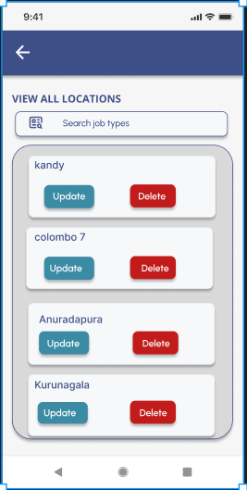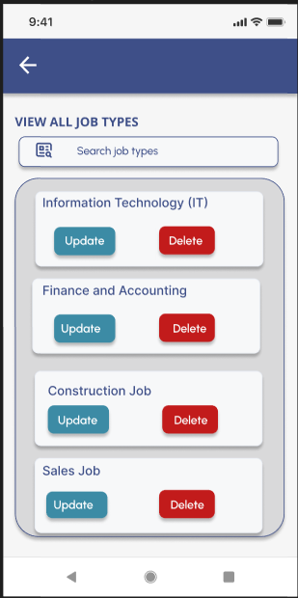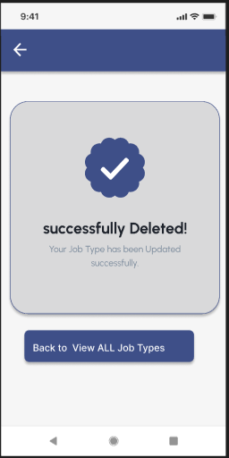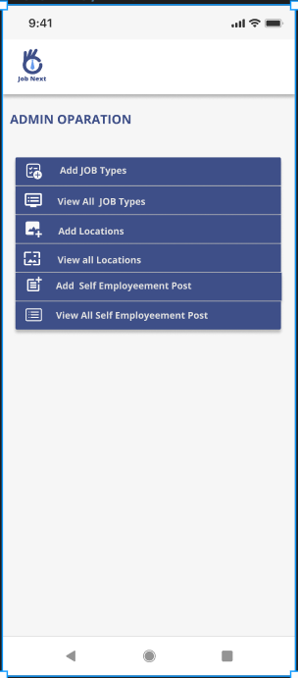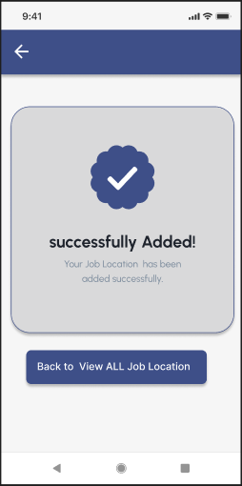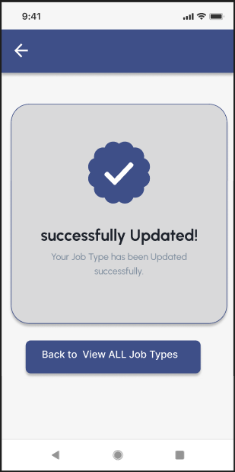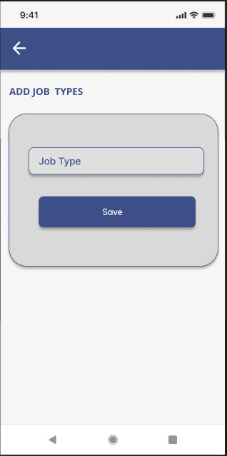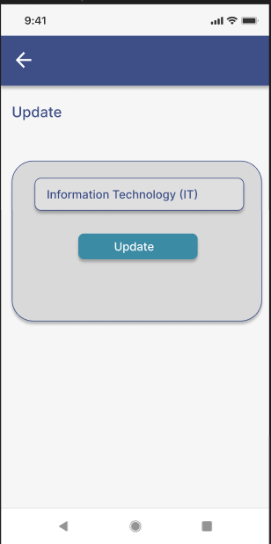**Member 1 -** **IT20642914 (Gamage B.G.A.C)**

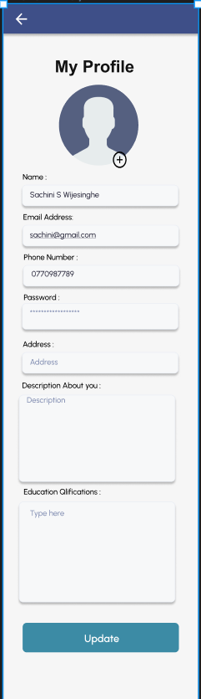**Member 2 - IT20641092(W.S.S Wijesinha)**

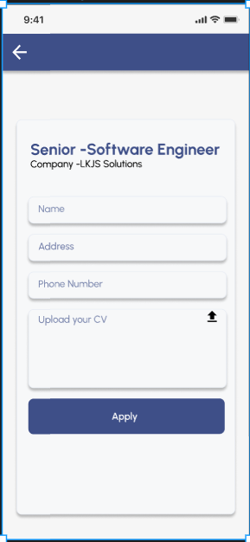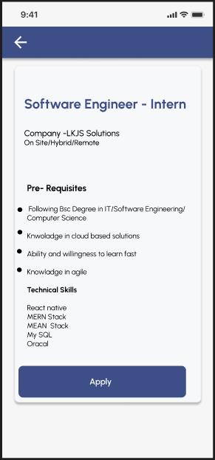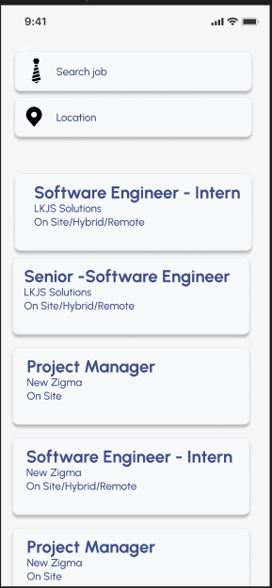

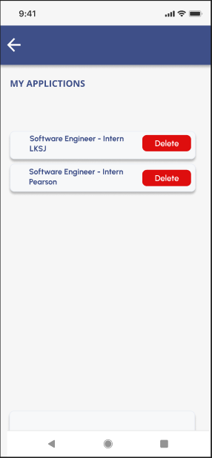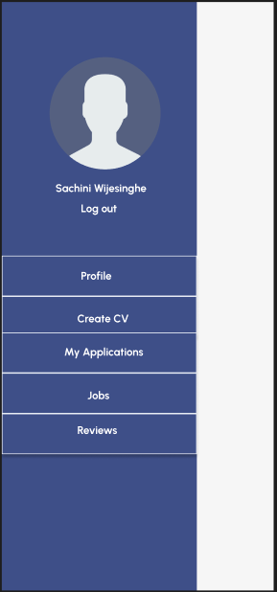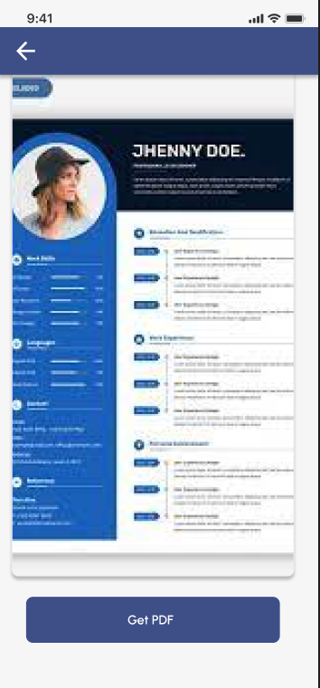

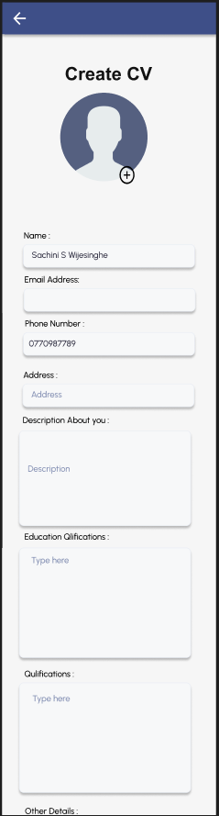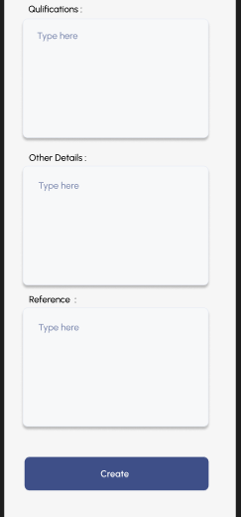

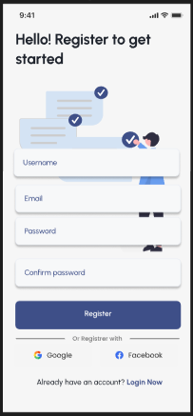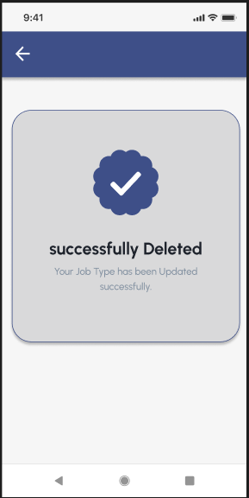

**Member 3 - IT20637064 (R.M.C Anuththara)**

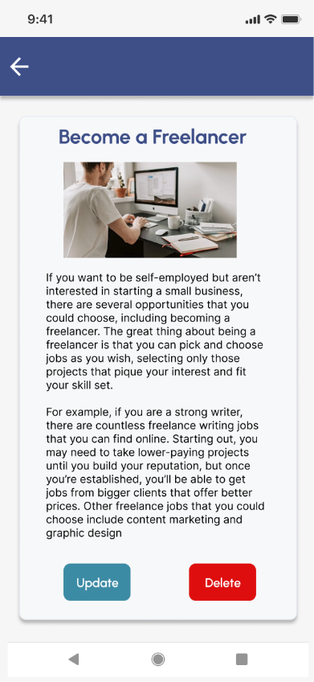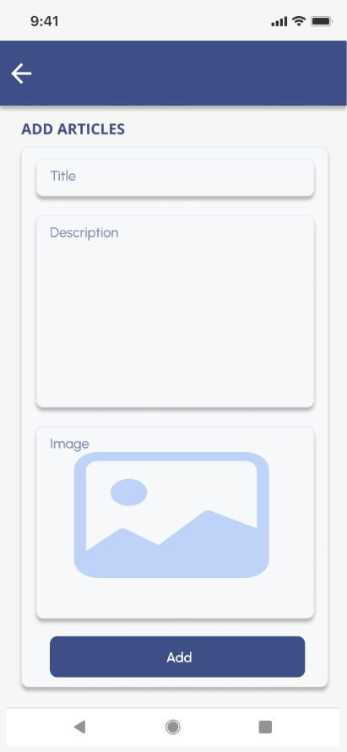

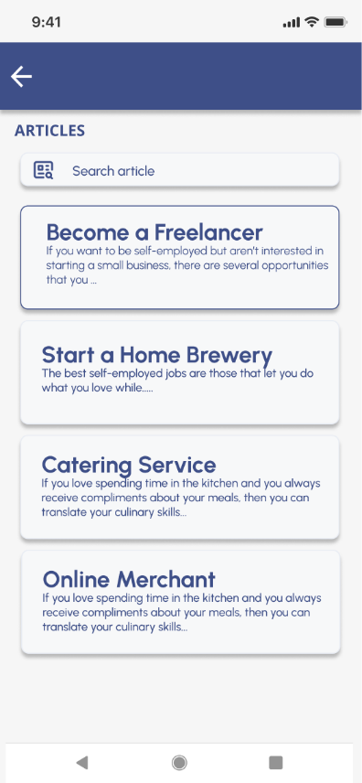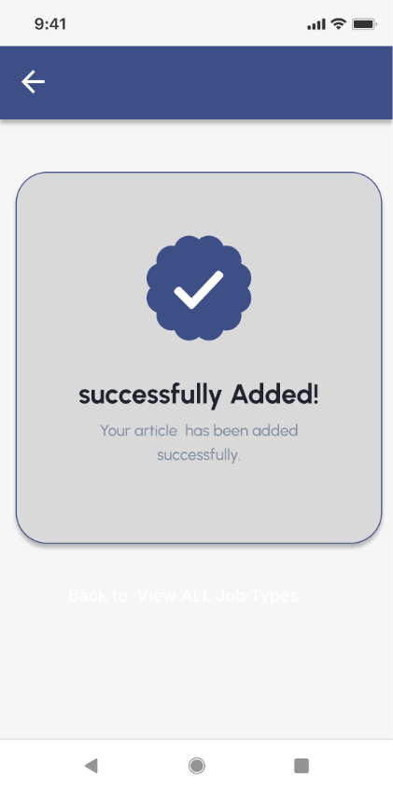

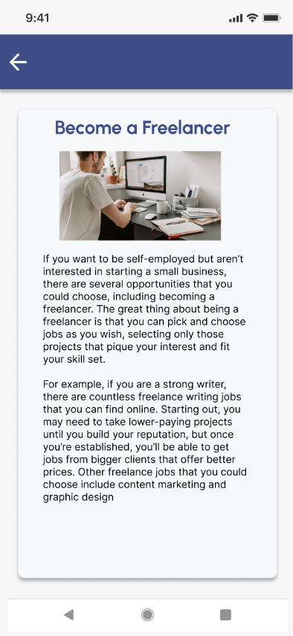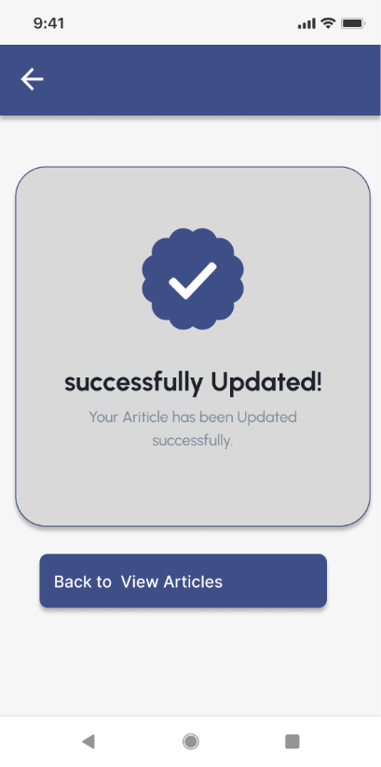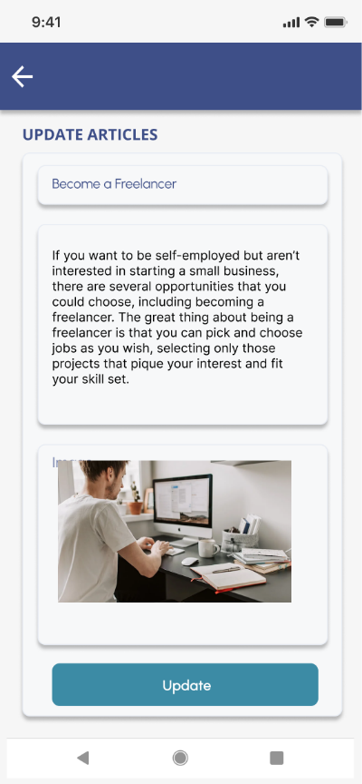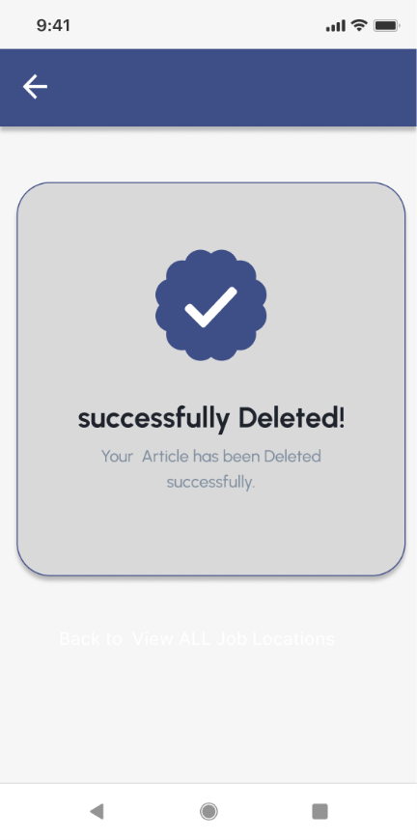

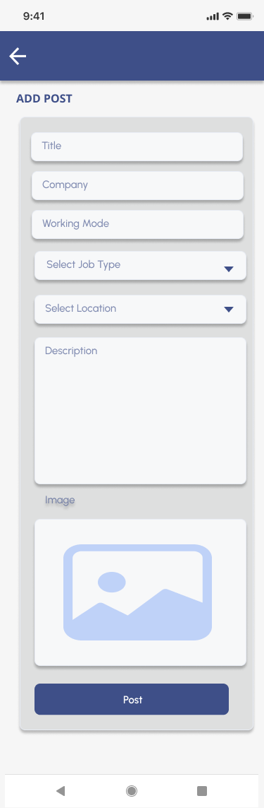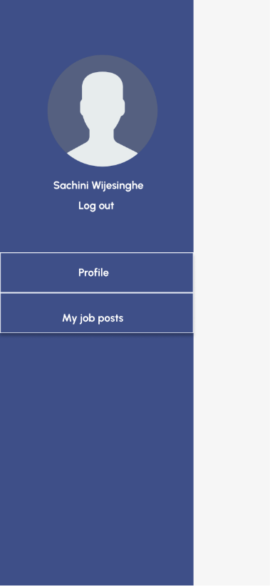**Member 4 - IT20639662 (Navodi P.T)**

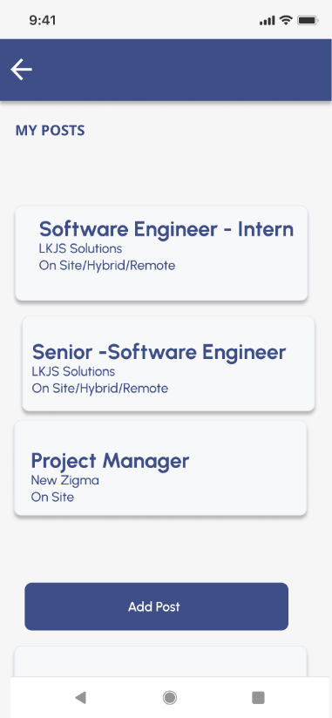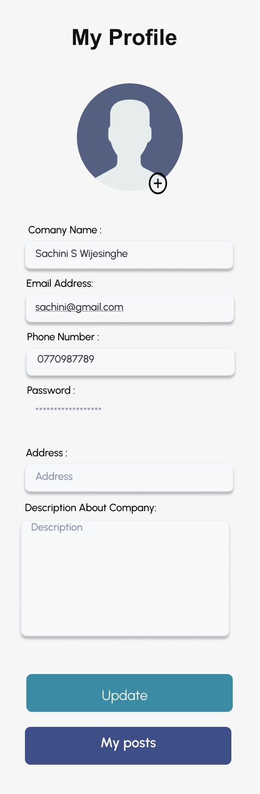

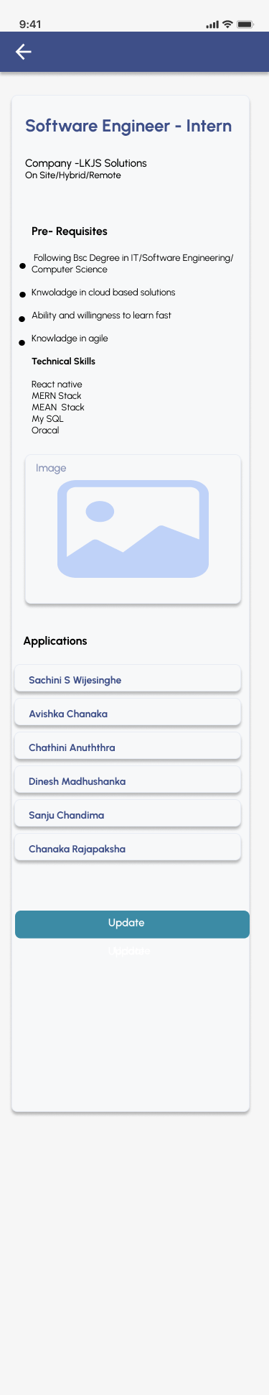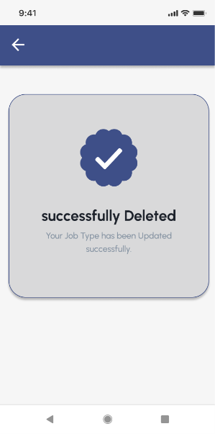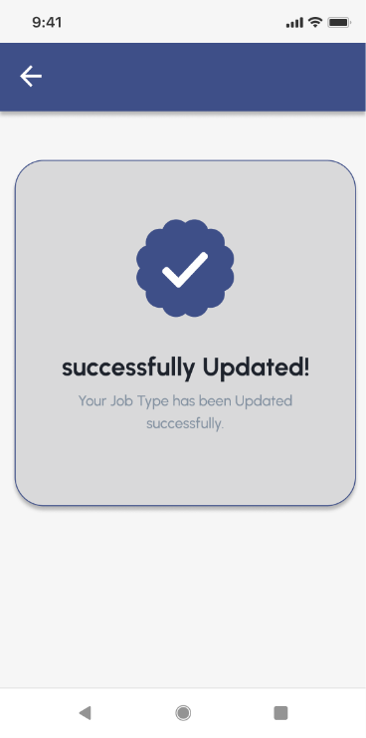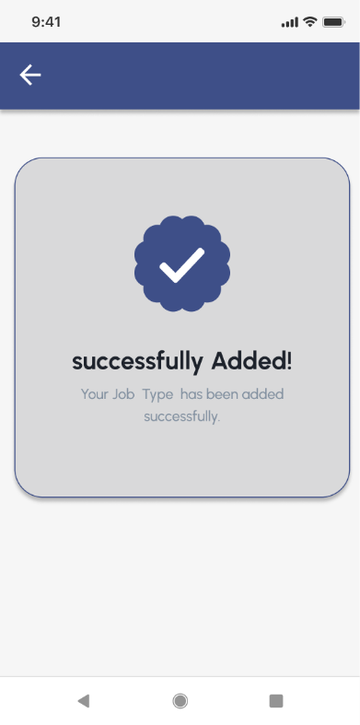

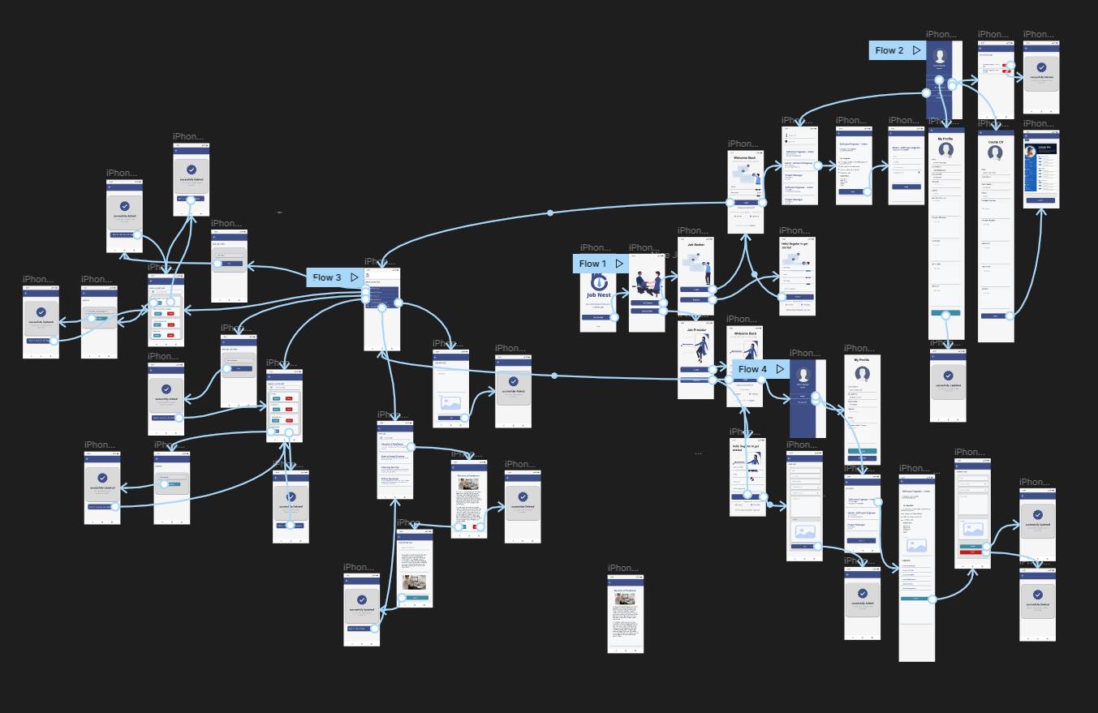**Prototype**

<https://www.figma.com/file/dspgKIOvxJ4bE444SVgmeX/Untitled?node-id=2%3A2>

# Milestone 6: User Feedback for your Prototype

# User Feedbacks

We provided a google form to get feedbacks about user interfaces which we have created for our Mobile application, and we got some feedbacks through that google form.

Below snapshots show those feedbacks

*Get started Page:*

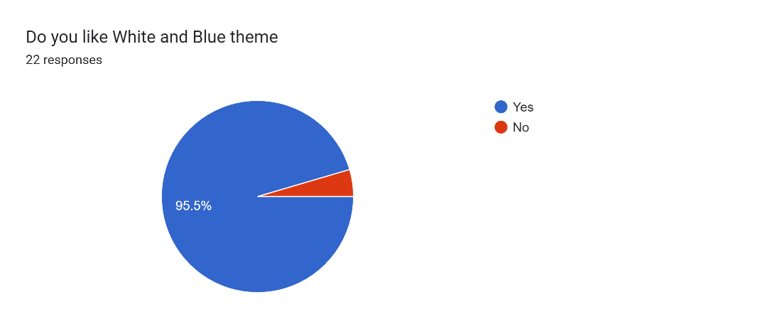

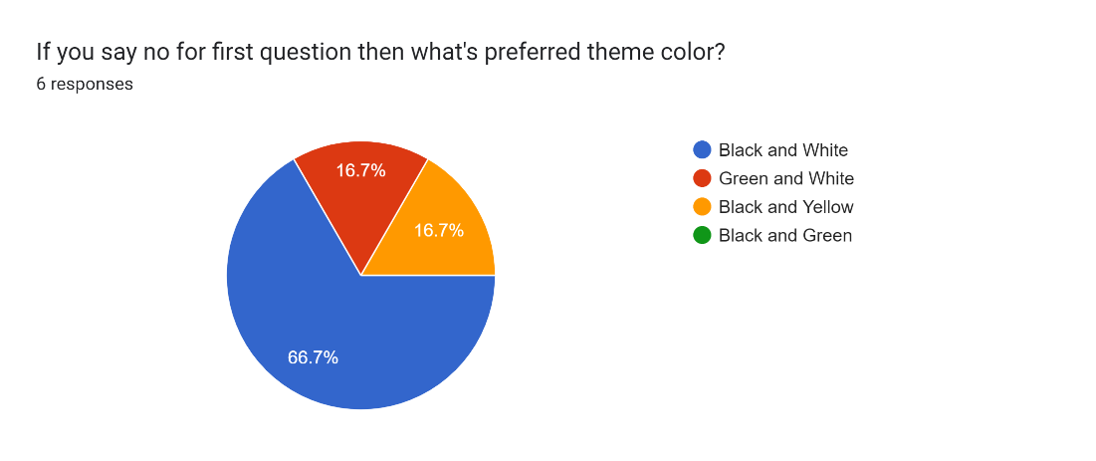

*Home Page:*

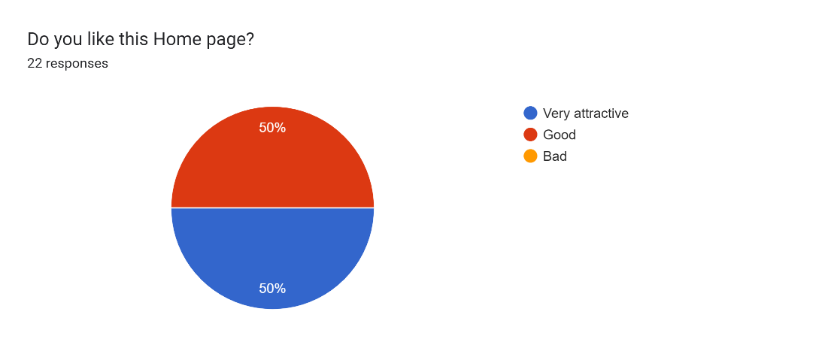

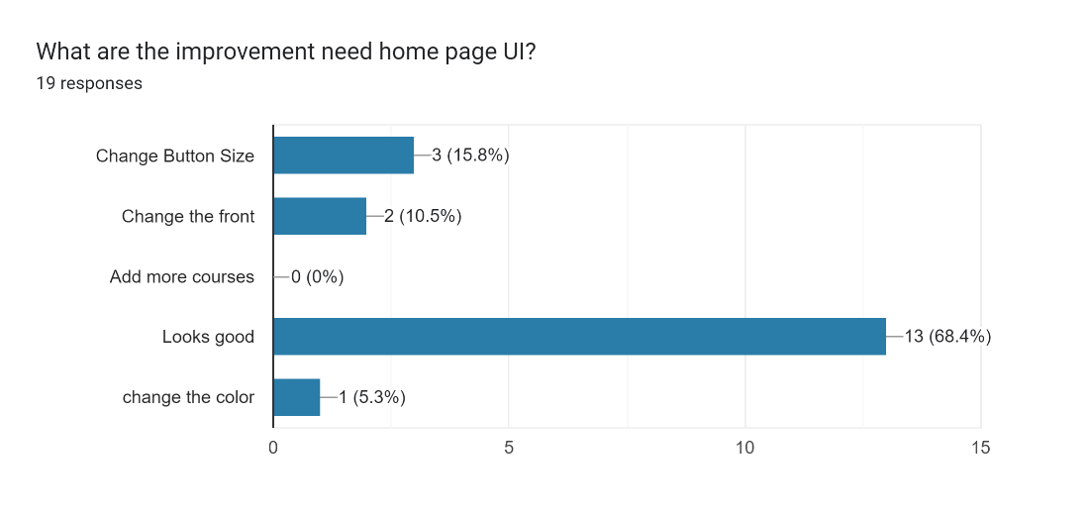

*Login Page:*

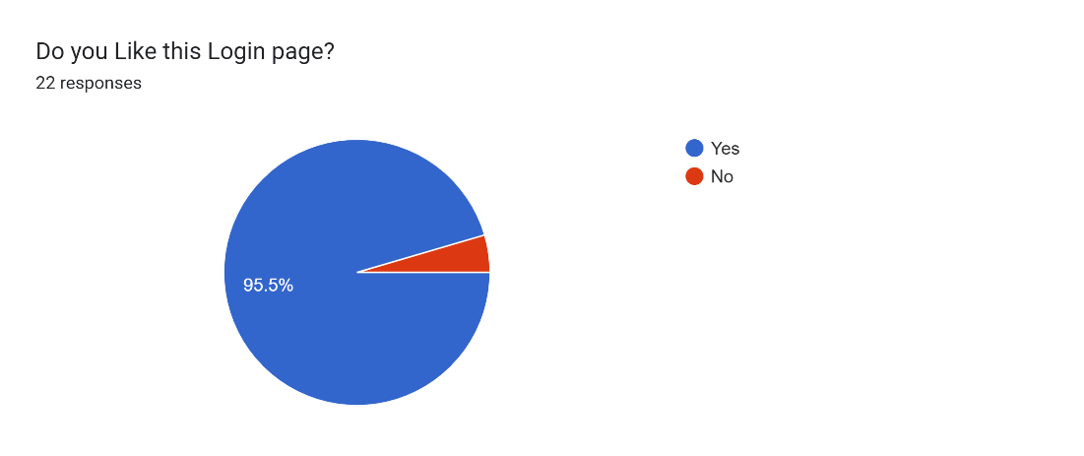

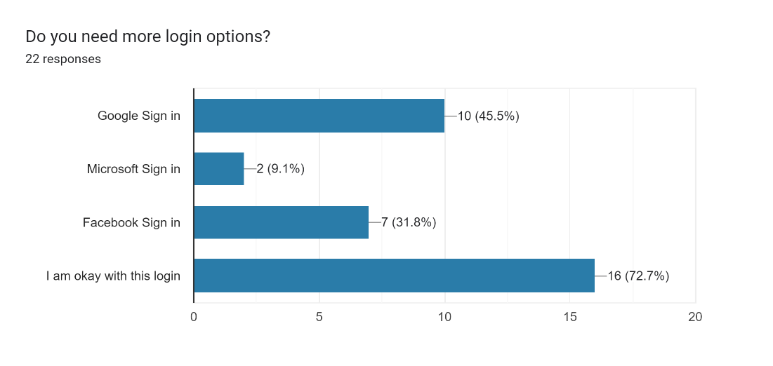

*Job vacancies View Page:*

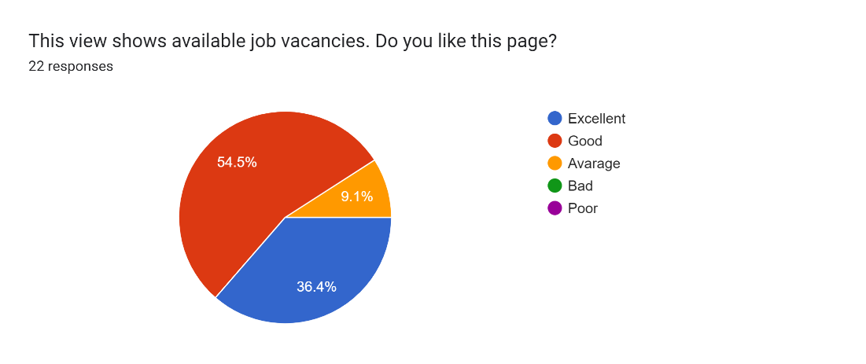

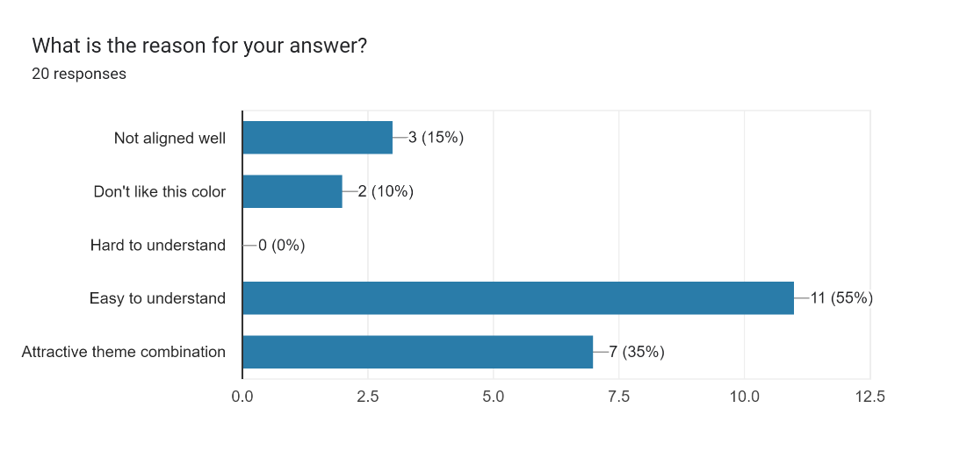

*Job vacancy in detail Page:*

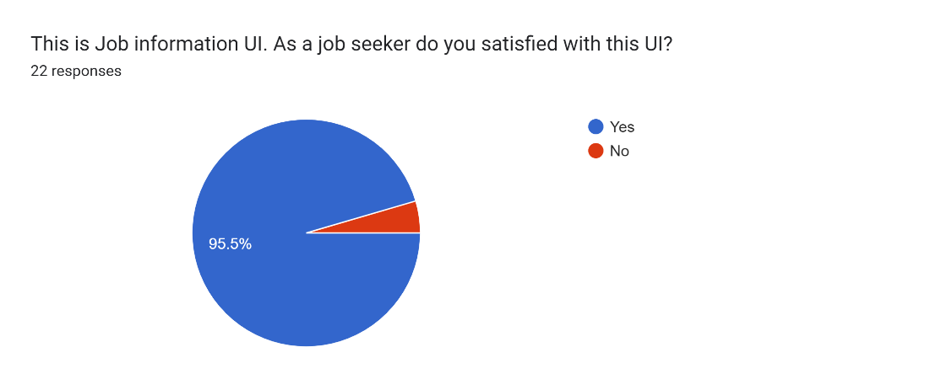

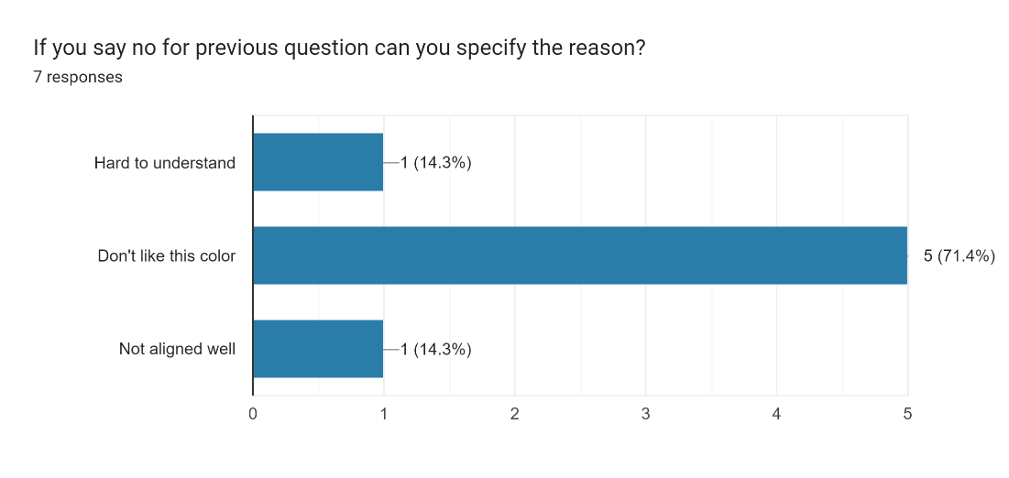

*Add job post Page:*

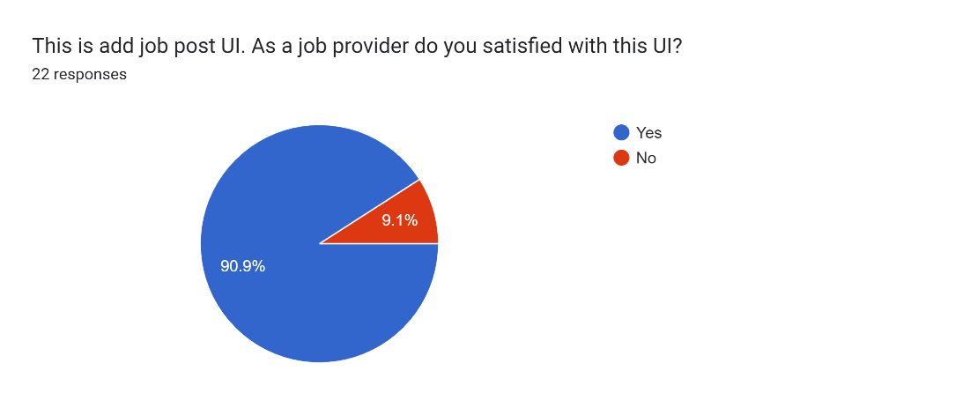

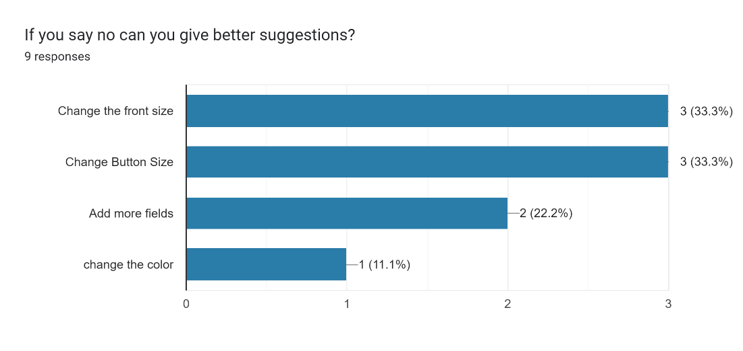

*Admin panel:*

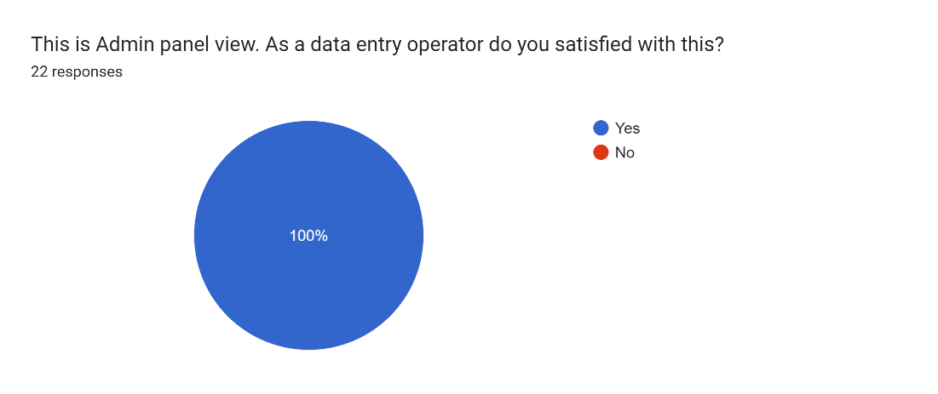

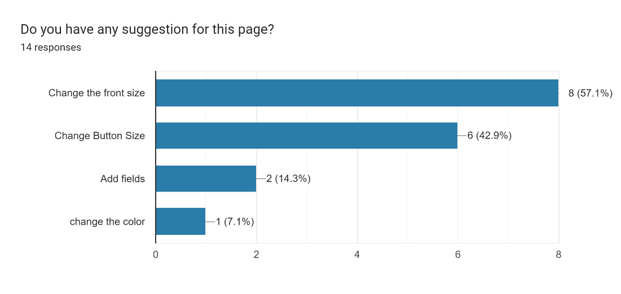

*View locations Page:*

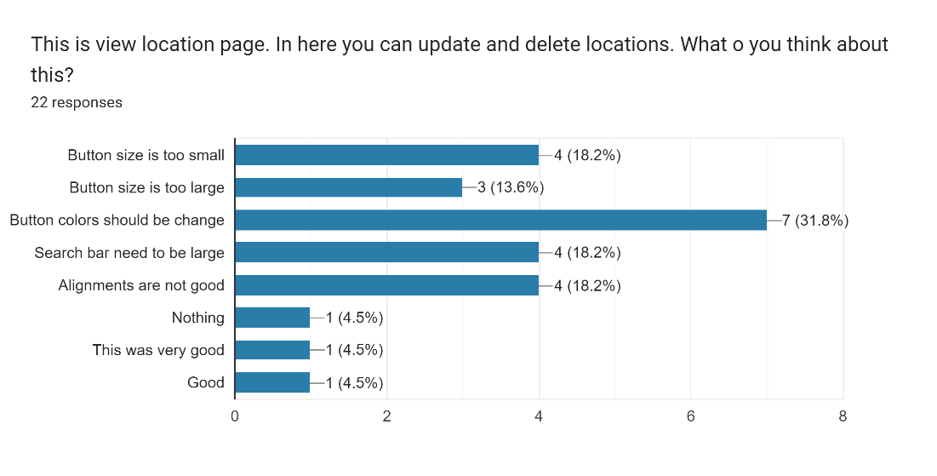

*Notify Alert:*

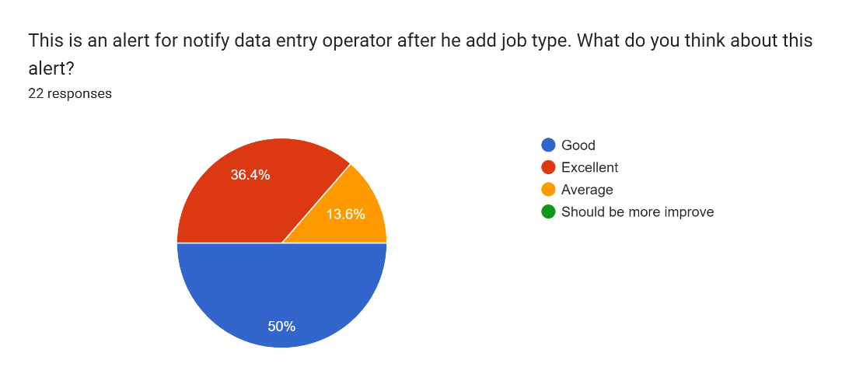

*Job articles Page:*

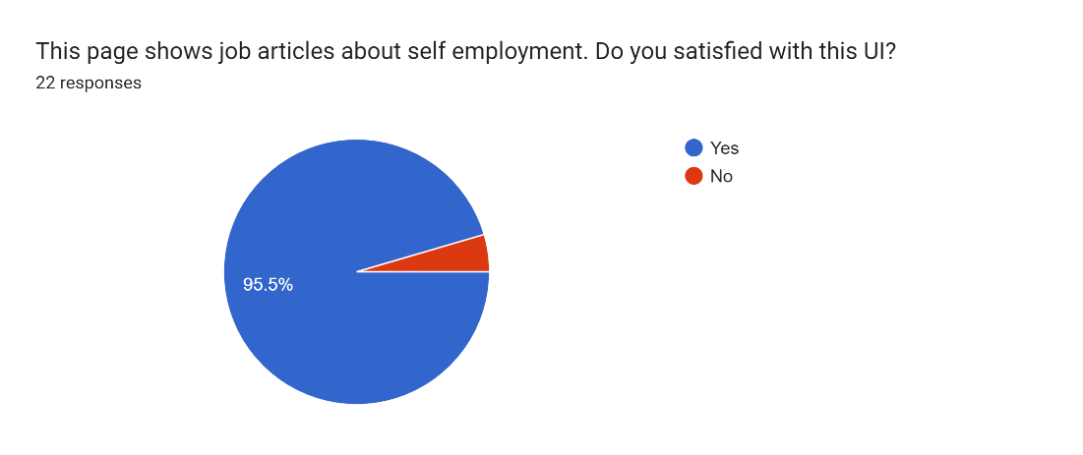

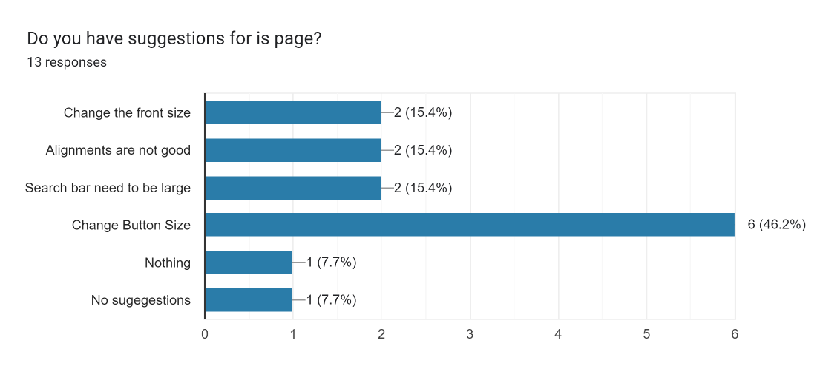

*Job article in detail Page:*

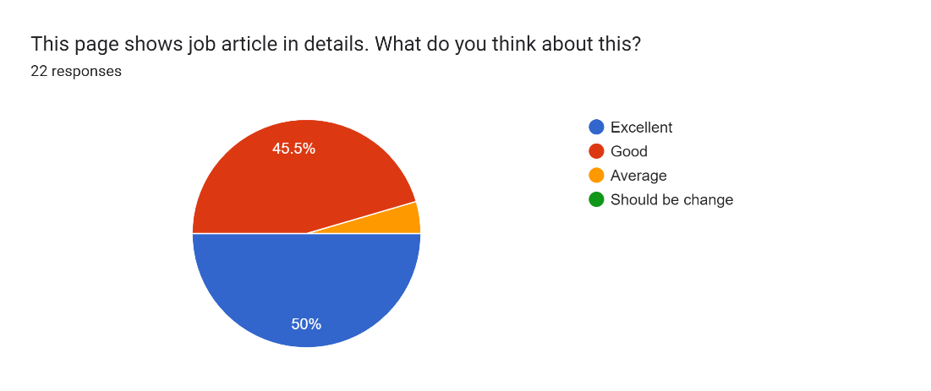

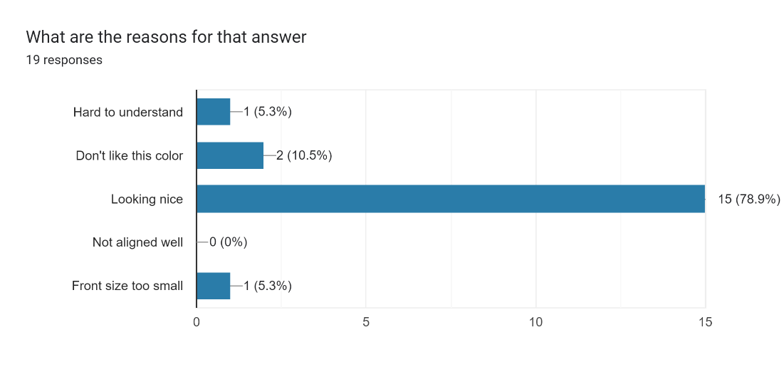

## **Prototype (Version 2.0)**

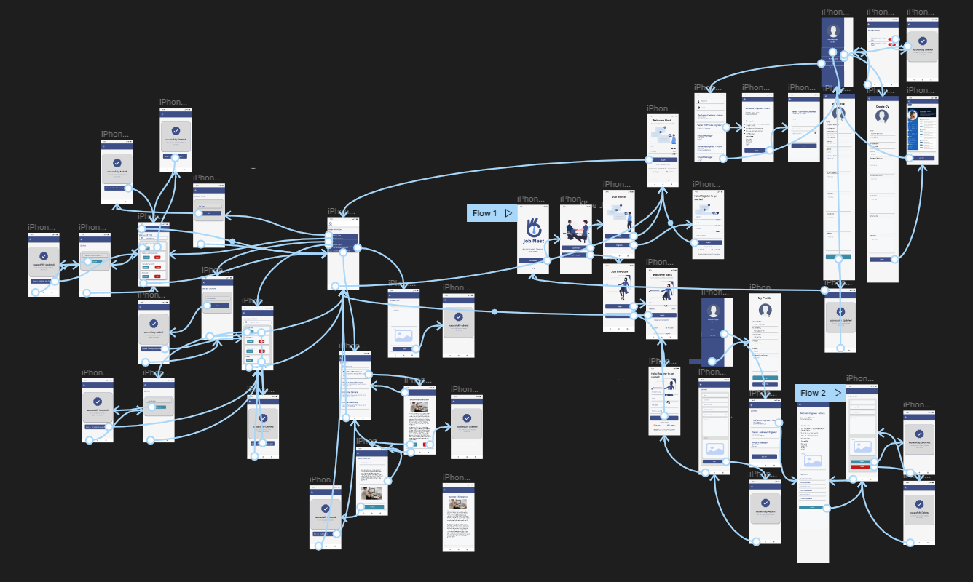

**Improvements made:**

1. Changed button and font colors
2. Changed font size
3. Added delete icon for course view page
4. Fixed alignments
5. Added more tabs for courses

## **Evidence**

**Prototype link:**

Prototype(users)= [https://www.figma.com/proto/dspgKIOvxJ4bE444SVgmeX/Untitled?page- id=2%3A2&node-id=2%3A26&viewport=806%2C41%2C0.12&scaling=scale-down&starting-point-node-id=2%3A26&show-proto-sidebar=1](https://www.figma.com/proto/dspgKIOvxJ4bE444SVgmeX/Untitled?page-%09id=2%3A2&node-id=2%3A26&viewport=806%2C41%2C0.12&scaling=scale-down&starting-point-node-id=2%3A26&show-proto-sidebar=1)

Prototype (Admins)= <https://www.figma.com/proto/dspgKIOvxJ4bE444SVgmeX/Untitled?page-id=116%3A270&node-id=183%3A304&viewport=733%2C680%2C0.12&scaling=min-zoom&starting-point-node-id=183%3A304&show-proto-sidebar=1>

**Video link:**

[**https://mysliit-my.sharepoint.com/:f:/g/personal/it20642914_my_sliit_lk/EoLxwJ98JEpJn4efekKQNkMBX8TbQKea_czNNhaf_qE0vw?e=vFhbNo**](https://mysliit-my.sharepoint.com/:f:/g/personal/it20642914_my_sliit_lk/EoLxwJ98JEpJn4efekKQNkMBX8TbQKea_czNNhaf_qE0vw?e=vFhbNo)

**Form link:**

<https://docs.google.com/forms/d/e/1FAIpQLSd5ZBxBkUNwrEE8DjIppBNVYFAFqUvVx05oCZY6V4xI-nLM1g/viewform?usp=sf_link>

**GitHUB**

[**https://github.com/avishka05/UEE-SEJ006**](https://github.com/avishka05/UEE-SEJ006)

### User Feedback for prototype (Version 2.0)

# Test Script

Hi, thank you for accepting our request and for taking your valuable time to participate to our user feedback session. Before going further, I will explain briefly about this test. We have re-implemented the mobile application. So, we have come up with a new prototype. We are just testing this prototype behavior. So, please feel free to mention at any time if there’s anything you like, dislike, if you are confused etc.

#### Get started page

|  |  |
| --- | --- |
| **Question** | **Answer: Interviewer** |
| This is our get started page and when you click on the “get started” button in the bottom, you can see our home, Page. What do you think about this page? | It displays look more attractive and image is also good |
| Do you like this theme color? Blue and white | Yes. It’s nice |

#### Home page

|  |  |
| --- | --- |
| **Question** | **Answer: Interviewer** |
| This is our home page. In here we can search jobs by using this search bar and you can select any course.  What do you think about this screen? | All these screens are attractive and there are more courses than in the previous UI.  This is also same. |

#### Login page (Job provider)

|  |  |
| --- | --- |
| **Question** | **Answer: Interviewer** |
| This is our sign in page and if you want to sign in as Job provider, you can click on the “Job provider” button. What do you think about this component arrangement? | Yeah, I think it's OK and it's fine. |
| Do you have any suggestions for this page | Yeah, I think if the color combination becomes dark it’s better. |

#### Sign-up pages

|  |  |
| --- | --- |
| **Question** | **Answer: Interviewer** |
| These are our signup pages. We designed 2 signup pages for each user level. What do you think about these screens? | Yeah, using two processes for different user levels is good. It’s easy to understand. |
| Do you have any doubts or confusions on these views? | no confusions |
| Do you have any suggestions? | No, nothing for now. |

#### Add Job Post page

|  |  |
| --- | --- |
| **Question** | **Answer: Interviewer** |
| This one is “Add Post” page. Users can add their posts from this interface. Do you like this page? | Yes. It’s good look and alignments are also good |
| Do you have any suggestions? | No, I think it is simple and good. |

#### CV Generation

|  |  |
| --- | --- |
| **Question** | **Answer: Interviewer** |
| In this interface users are allowed to enter their details and generate CV according to the common template. What do you think about the components that we have used here? | I think Input fields are enough to type. It is a good idea to include the topic field and details fields both. All components are good. |
| As you can see, we have got some details from the user registration form. But they can be editable if the user wants to change some details, they can edit them. What do you think about the new view of that profile? | I think it’s better now. It is an easy method because only the details that we want to change, we can edit. |
| Do you have any confusion on this view? | No. It is good. |

#### Job Apply page

|  |  |
| --- | --- |
| **Question** | **Answer: Interviewer** |
| In this interface users can apply for a specific job by inputting user's details. What do you think about this interface? | Text is well aligned. Input fields are enough to input the details. Font size is good. And the colors that you used are good, it is comfortable to the eye.  CV upload is good. |
| Do you have any suggestions? | No, this screen is good |

**Admin Dashboard**

|  |  |
| --- | --- |
| **Question** | **Answer: Interviewer** |
| When you login as admin you will direct to the admin dashboard. What do you think about that interface? | It's simple and cool, anyone can identify the flow .so it's good |
| What do you think about colors and fronts? | Front size is good and color combination is very good |

#### My Posts page

|  |  |
| --- | --- |
| **Question** | **Answer: Interviewer** |
| This page allows the users to view their posts that have been published and we have re-arranged the alignments. What do you think about this new view? | It looks nice and user-friendly with this new view. |
| Do you have any suggestions? | No |

#### View All job Types Page/ View All Locations

|  |  |
| --- | --- |
| **Question** | **Answer: Interviewer** |

|  |  |
| --- | --- |
| In these two screens admin can view all added job types and locations it will allow admins to change and delete job types and job locations if they want.  What do you think about those two screens? | It is good and easy. Alignment of buttons and text are well arranged. And the color combination is good. |
| Do you have any suggestions? | No, actually both screens are good. |

#### View All Articles

|  |  |
| --- | --- |
| **Question** | **Answer: Interviewer** |
| From this page users can view all the self-employment articles. And users are allowed to search the article by using the article name. What do you think about the appearance and the functionality of this page? | Yeah, well understood when I look into this page. The search box is well positioned on the top of the page. It is good.  Font sizes are good, and posts are well arranged. |
| Do you have any suggestions? | Actually, this is good, so I don’t have any suggestions |

#### Add Article page

|  |  |
| --- | --- |
| **Question** | **Answer: Interviewer** |
| In this interface admin can add articles. What do you think about this interface? | Input fields are enough to input the details. Font size is good, and fonts are also clear. |
| Do you have any suggestions? | Actually, this is good, so I don’t have any suggestions |

#### Overall Application

|  |  |
| --- | --- |
| **Question** | **Answer: Interviewer** |
| Ok, these questions we are mainly focusing on the entire application. So, what do you think about our color icons and images that we have used? | yes, all are looking nice |
| Ok, Finally, do you have any suggestions to improve this? | I mentioned them before. Nothing more than that. |
| Ok. Then did you recommend this our app to your friends and family members? | Yes of course, If all functions are work well, I will surely recommend your app with my friends and family members |

# Milestone 7: Implementation

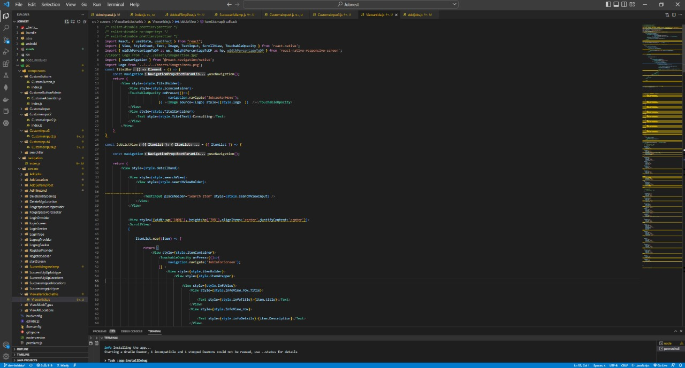

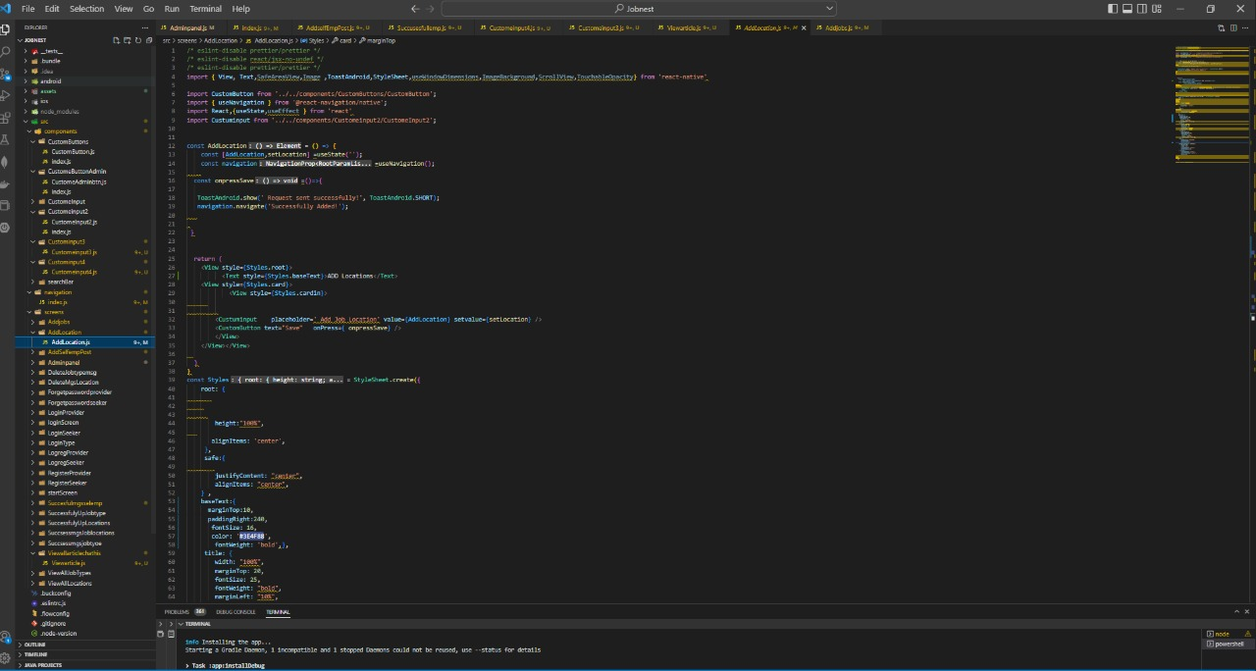

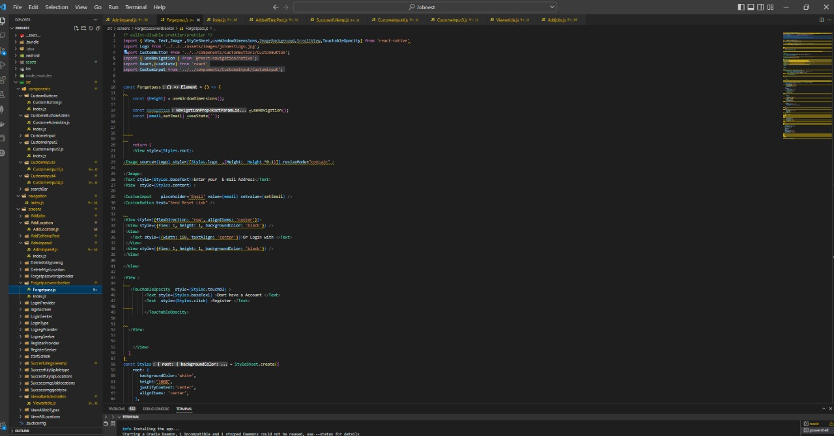

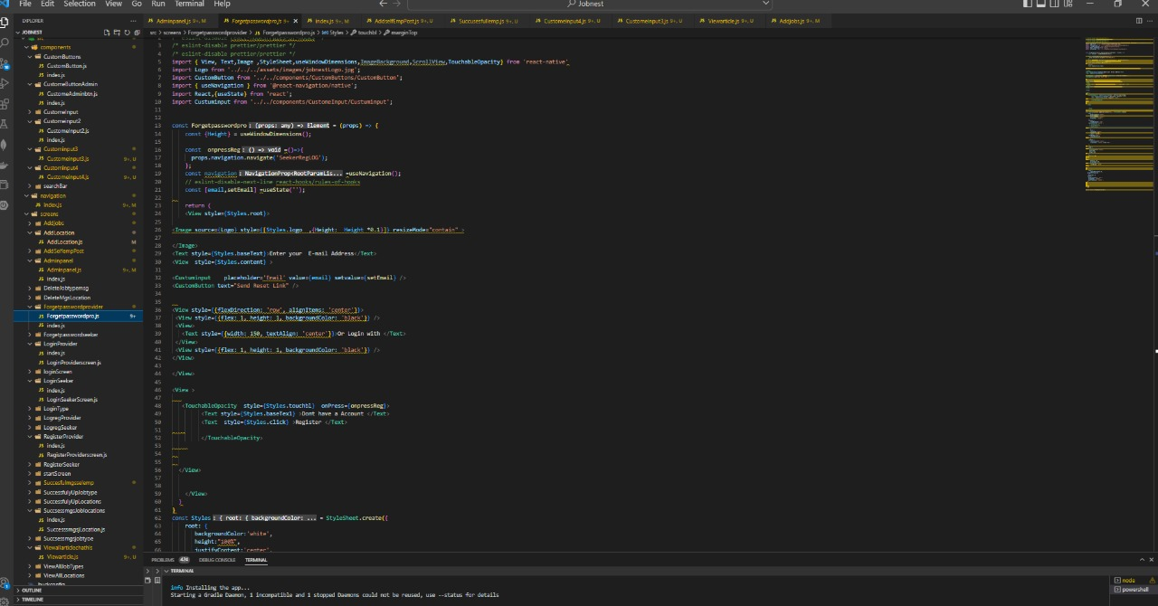

# 12 Requirement Specification

## 12.1 Usability Goals

Usability is a measure of how well a specific user can use a product/design to achieve a defined goal effectively and efficiently. As Designers, we usually measure a design’s usability from wireframes to the final deliverable.

So, we need to achieve some usability goals from our product. They are effective to use, efficient to use and easy to learn. We want to give a product which supports users in actions accurately and can perform tasks quickly. Another thing is new users need to accomplish goals easily. So, we need to achieve that goal. A product should be a memorable one. Then every user can use it easily. So, it is also a usability goal of ours.

## 12.2 User Experience Goals

When we designing a product, we should achieve user experience goals. So, we also want to achieve some desirable aspects as user experience goals such as satisfying, helpful, supporting, creativity and experiencing. We want to avoid from undesirable aspects also. They are boring, unpleasant and frustrating. We want to give a good product by achieving those user experience goals.

## 12.3 Functional Requirements

Functional Requirements

* Sign up/Sign in Course registration
* Feedback Publish announcements
* Add/delete courses function Course authorization
* View student report function Fixing issues
* Add/delete notice function. Upload/delete live sessions

Non-Functional Requirements

* Performance
* Security
* Usability
* Reliability

## 12.4 Hierarchical Task Analysis

12.4.1 Identify the Primary Procedure ➔ First we identify the what are the users expect from the system. For that we planned user researches

12.4.2 List the Main Tasks ➔ After identify the main procedure we were going to list the main tasks of the application.

12.4.3 List the subtasks ➔ We broke main tasks into subtasks after identify the main tasks.

# 3 Design Principles

Any good product is built on a set of principles called design principles, which aid teams in making decisions. Our team's decision-making will be guided by a few straightforward concepts.

So, we have used some design principles while we are designing our product. Among them first one is focusing on alignment. Center, right, or left-aligned texts are the most common alignments which we have used. We gave extra visual weight for some important texts in the user interfaces used larger or bolder fonts for our typography, placed our most important message physically higher than other pieces of information. So, we used hierarchy design principle like that.

Using repetition is another design principle which we have used. We used Repeating colours, fonts, words, and shapes. It will be easy to remember our important information of application to users. Balance is also an important design principle while designing an application. So, we used that also. As an example, dark elements are balanced out by light ones by us.

Optimizing colour and leaving negative spaces are other design principles which we have used for our application. We all tried our best to give a user-friendly design by using those design principles.

# Project Management

## 14.1 Meetings

We conducted more meetings with our team members to discuss our projects tasks. First, we got a meeting to decide our leader, SDG and familiar with each team members. After that for each milestone, we conducted a meeting to discuss the task plan and divide the tasks to each member. Then start-up meetings are conducted daily to see our daily progress. It was only 10-15-minute meeting. We used Microsoft team platform to conduct our meetings. This is the way that we have conducted our meetings to do our project tasks.

## 14.2 Risk Management

When we are completing the project time management was a risk to us. Because some of the team members are doing their internship. Other thing is we had lectures on weekend days. So, we had limited time to finish the overall product while doing other projects. So, managing time is the risk we had to consider when completing the project.

## 14.3 Milestones

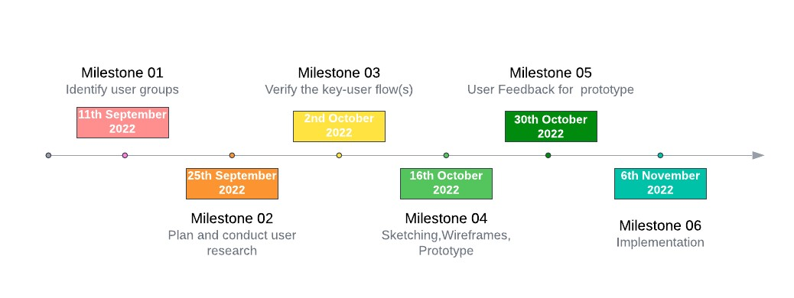

**Figure 13. 1: Milestone Timeline**

## 14.4 Problems Encountered

While doing the project tasks, one of the team member’s laptop was broken. That was the unexpected obstacle that we had faced. Because if one member could not finish his/her tasks, we will not able to finish overall tasks.

But we conducted meetings to address that problem. We shared the laptop screen from another member’s laptop and gave control to do the tasks.

# 15 Conclusion

After following all above steps which we have mentioned in this report, we all came up with a user-friendly product. In here we mainly focused to give a user-friendly and accurate product to users. So, we had to learn more techniques to build like that product. Design principles are one of the techniques among them. So, as a result we all gained a good knowledge about those techniques and the way of designing a good, user-friendly application from this project. Other thing is, we all worked as a strong team and helped each other at any time. It was a big reason to finalize this overall product at correct time. So, from this product, we learned the important of team working also.

We conducted user researches in more stages to get feedbacks of users while doing our project. It was a huge help to us to come up with a good product at last stage. So, User Experience is the most important thing that we have to consider when developing an application. That is the lesson which we all learned from this project.

# References

1. <https://www.themeum.com/avoid-udemy-build-your-elearning-site/>

1. <https://colorwhistle.com/top-e-learning-web-apps/>

1. <https://comparecamp.com/edmodo-review-pricing-pros-cons-features/>

[https://www.researchgate.net/publication/317074633_Recognizing_Possible_Limitations_of_ELearning_Through_EDMODO#:~:text=The%20results%20suggest%20possible%20limitations,thre at%20in%20online%20learning%20environments.](https://www.researchgate.net/publication/317074633_Recognizing_Possible_Limitations_of_E-Learning_Through_EDMODO#:~:text=The%20results%20suggest%20possible%20limitations,threat%20in%20online%20learning%20environments.)

## 15.2 Meeting Minutes

* Initial meeting - 60 minutes

* Milestone 1
  + Tasks discussion & dividing meeting - 60 minutes
  + Start-up meeting per day (a week) - 15 minutes
* Milestone 2
  + Tasks discussion & dividing meeting - 60 minutes
  + Start-up meeting per day (a week) - 15 minutes
* Milestone 3
  + Tasks discussion & dividing meeting - 60 minutes
  + Start-up meeting per day (a week) - 15 minutes
* Milestone 4
  + Tasks discussion & dividing meeting - 60 minutes
  + Start-up meeting per day (a week) - 15 minutes
* Milestone 5
  + Tasks discussion & dividing meeting - 60 minutes
  + Start-up meeting per day (a week) - 15 minutes
* Milestone 6
  + Tasks discussion & dividing meeting - 60 minutes
  + Start-up meeting per day (a week) - 15 minutes

## 15.3 Record Keeping

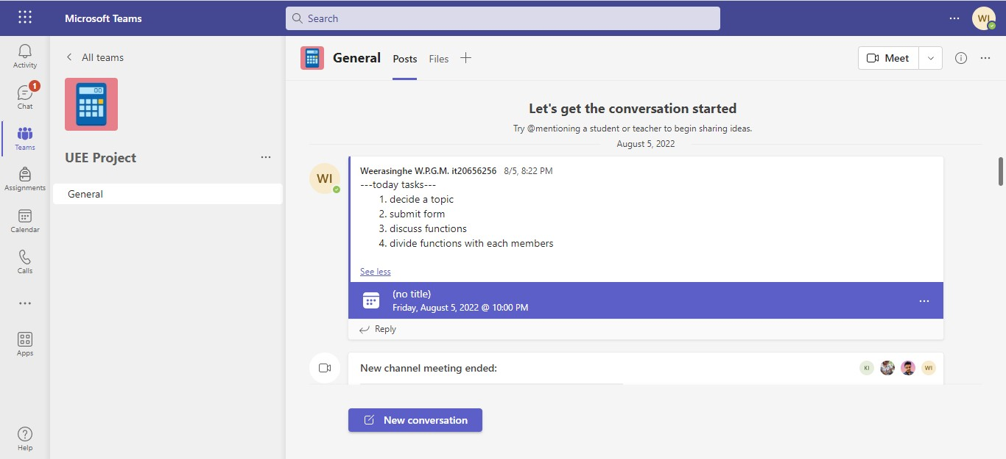

## 15.5 Contribution Table

|  |  |  |
| --- | --- | --- |
| **Student No** | **Student Name** | **Individual Contribution** |
| IT20642914 | Gamage B.G.A.C | Abstract  Created list of figures  Created list of tables  Background  Contributed to complete all milestones  Analysing competitor 1  Contributed to finalize the report |
| IT20641092 | Wijesinha W.S.S. | Introduction  Background  Design process  Contributed to complete all milestones  Analysing competitor 1  Contributed to finalize the report |
| IT20637064 | Anuththara R.M.C | Requirement specification  Design principles  Project management  Contributed to complete all milestones  Analysing competitor 2  Contributed to finalize the report |
| IT20639662 | Navodi P.T | Conclusion  References  Appendix  Contributed to complete all milestones  Analysing competitor 2  Contributed to finalize the report |